DATA OF BFS PROVIDED BY NUAA WP2 TEAM

Geometry of BFS model
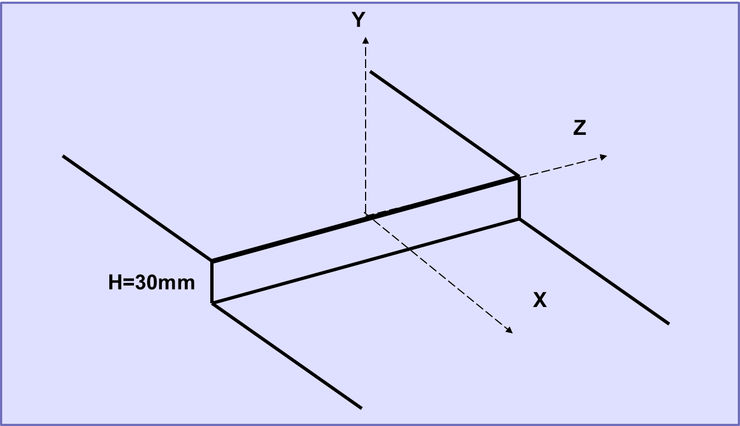

EXPERIMENTAL CURVES
BFS_ BL_ EXP_MCP_NUAA
Pressure coefficient
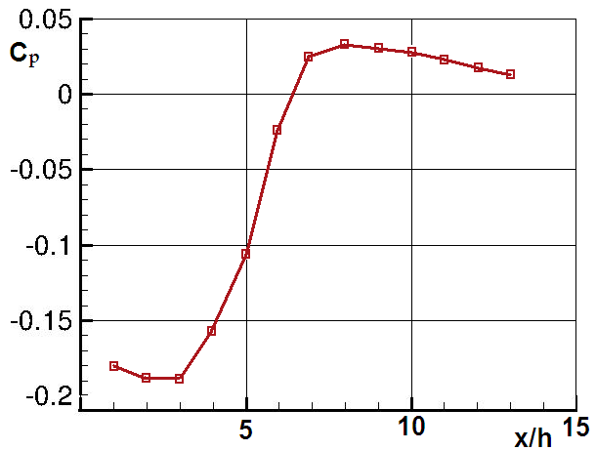

BFS_ BL_ EXP_MSF_NUAA
Skin friction
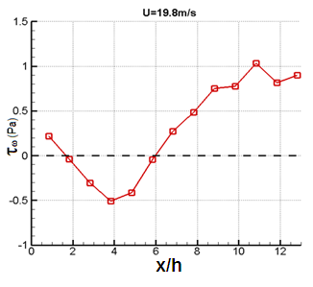

BFS_ BL_ EXP_MRA_NUAA

X/h=6 (free stream velocity U=19.8)

BFS_ BL_ EXP_TAS_NUAA
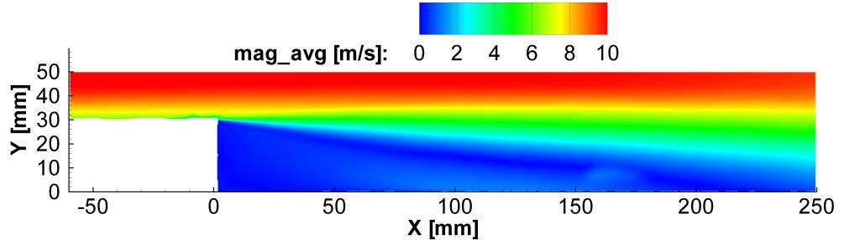

BFS_ BL_ EXP_TSS_NUAA
Profile of mean velocity, turbulence intensity, and Reynolds stress
X=1h
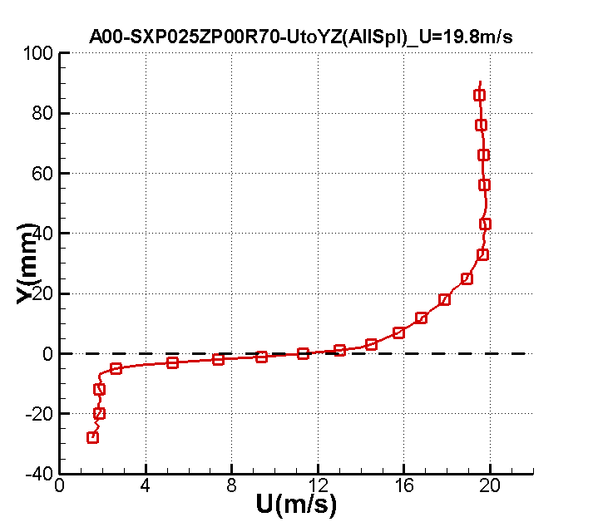
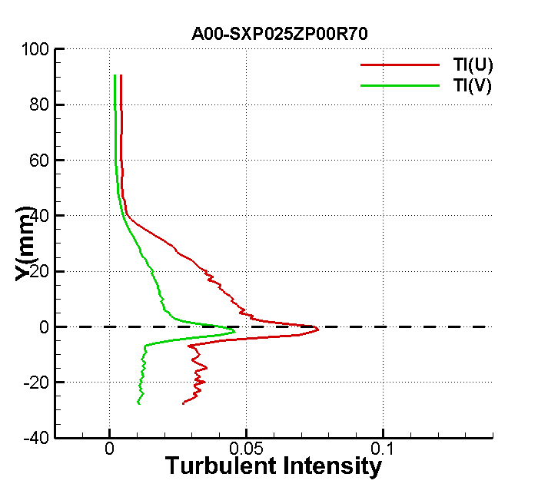
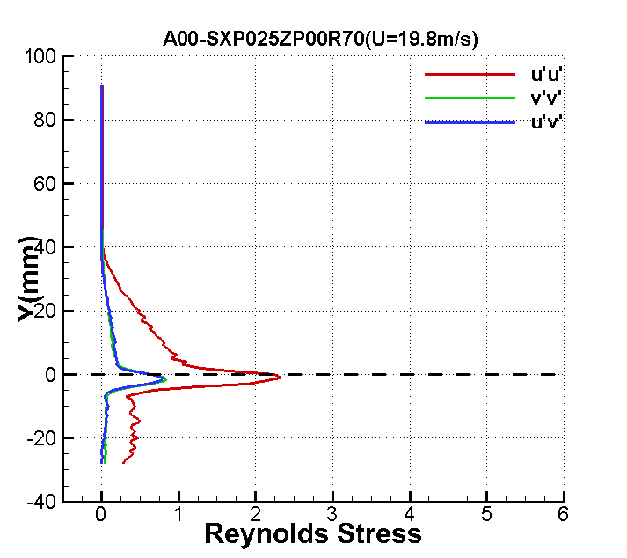

X=2h
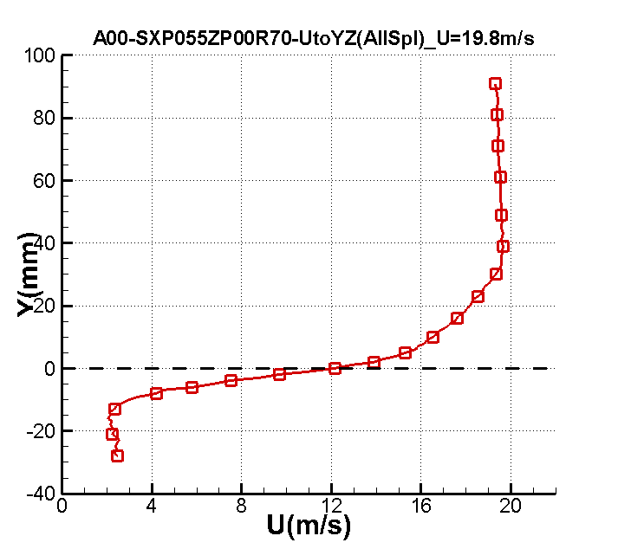
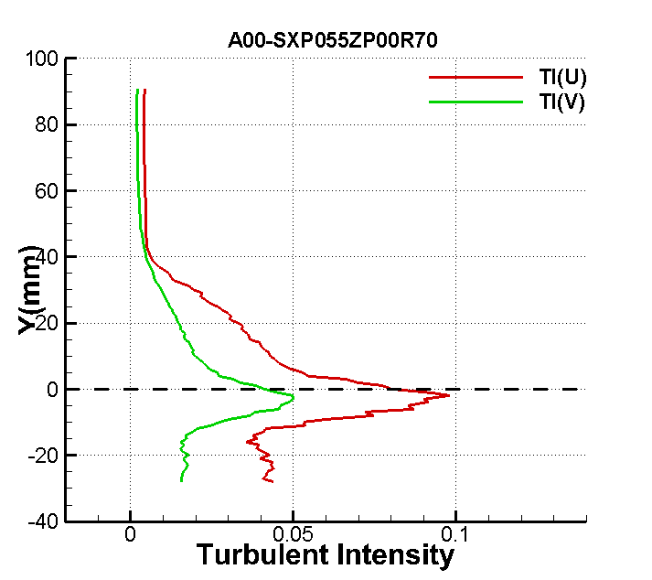
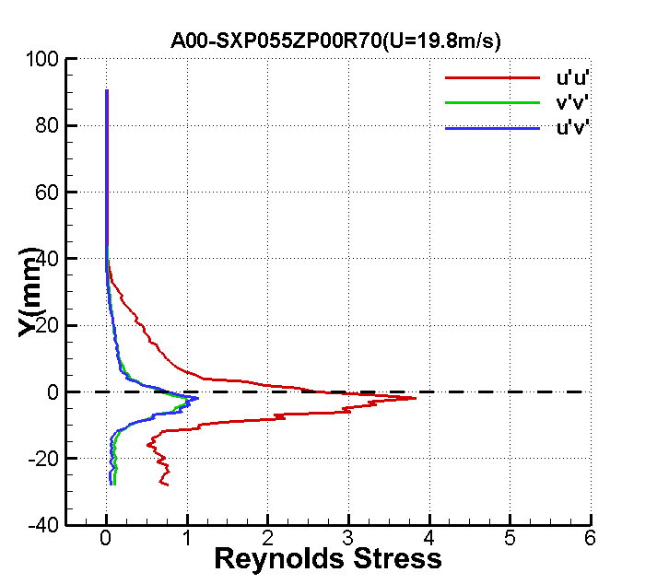

X=3h
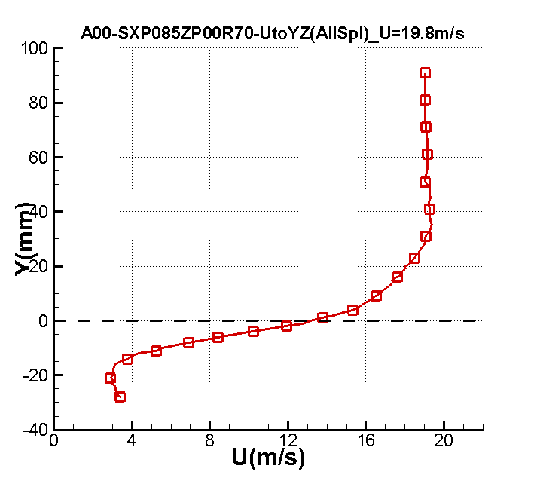
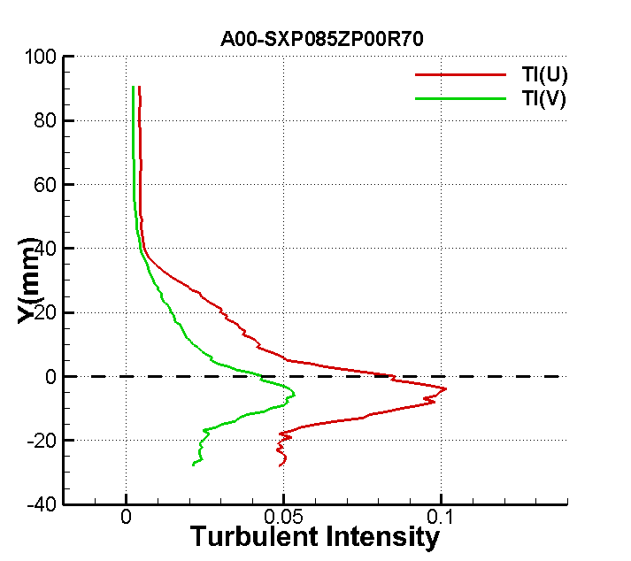
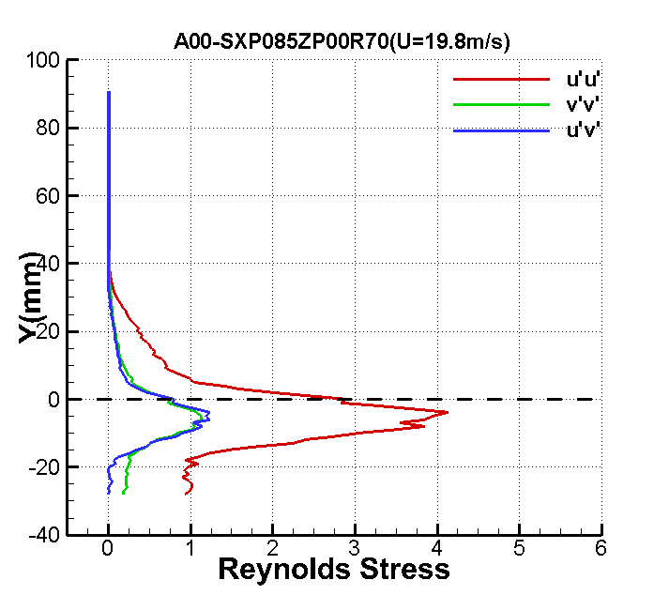
X=4h
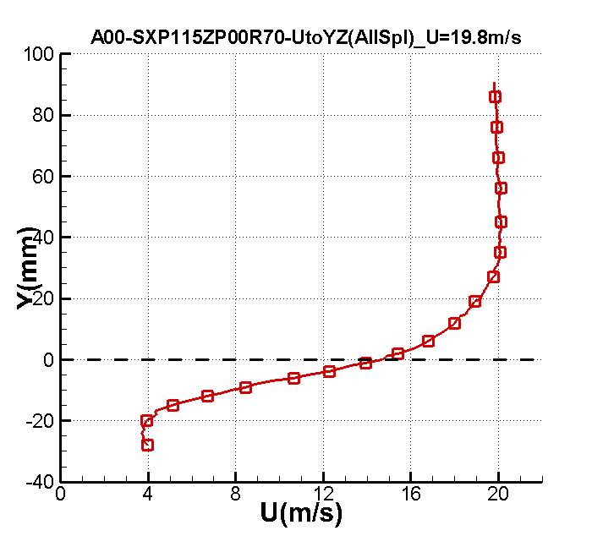
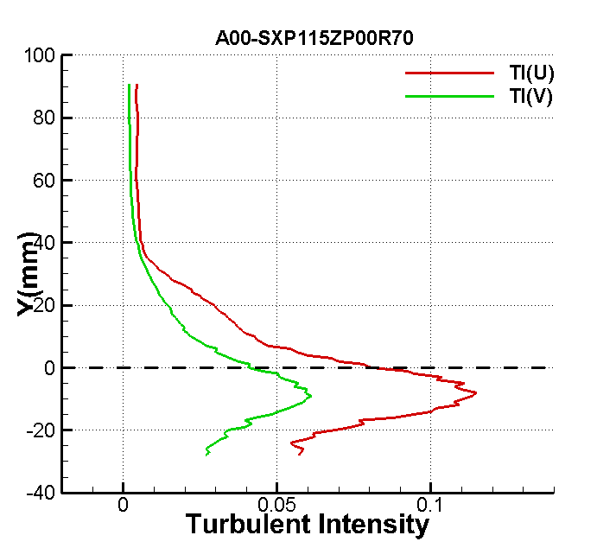
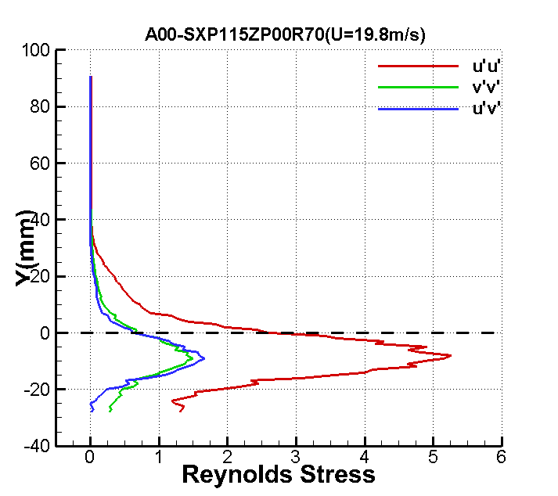
X=5h
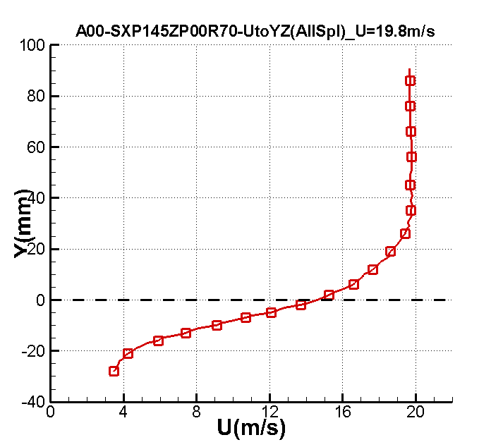
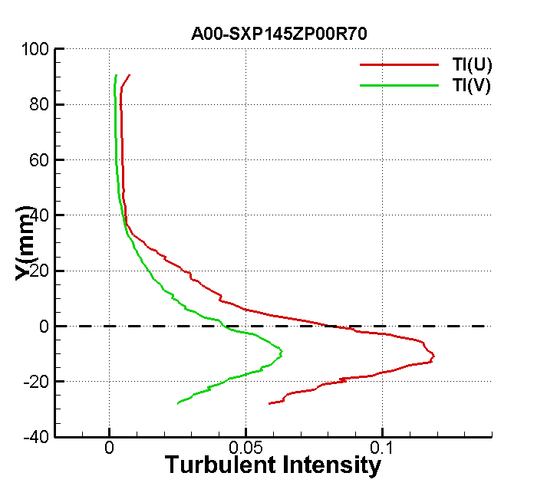
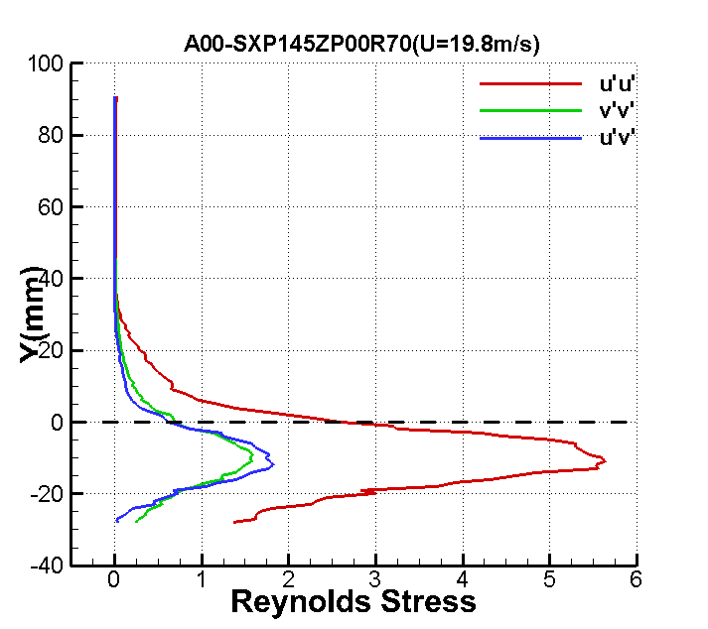

X=6h
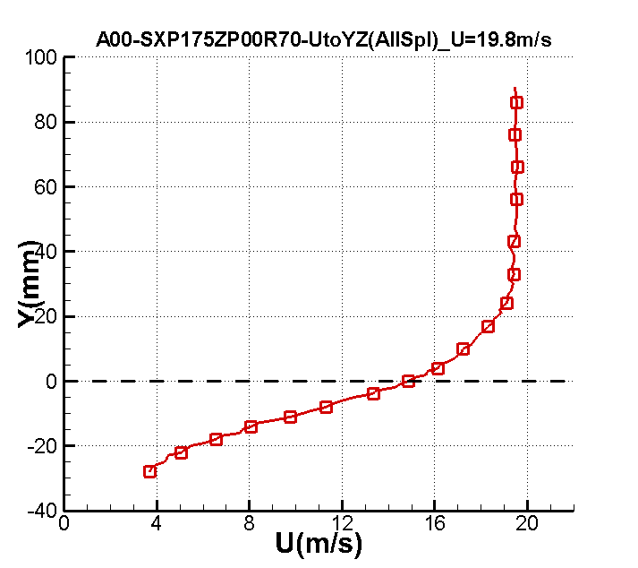
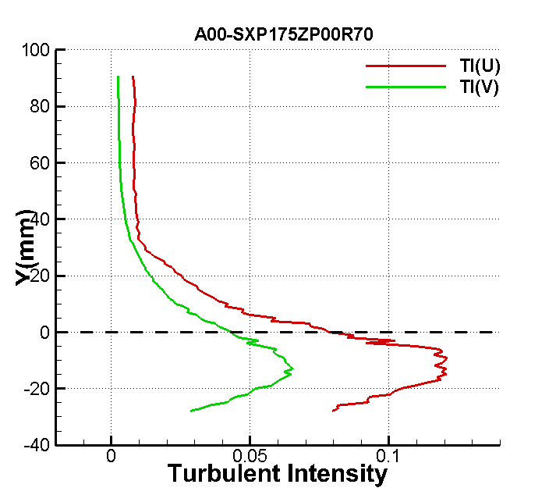
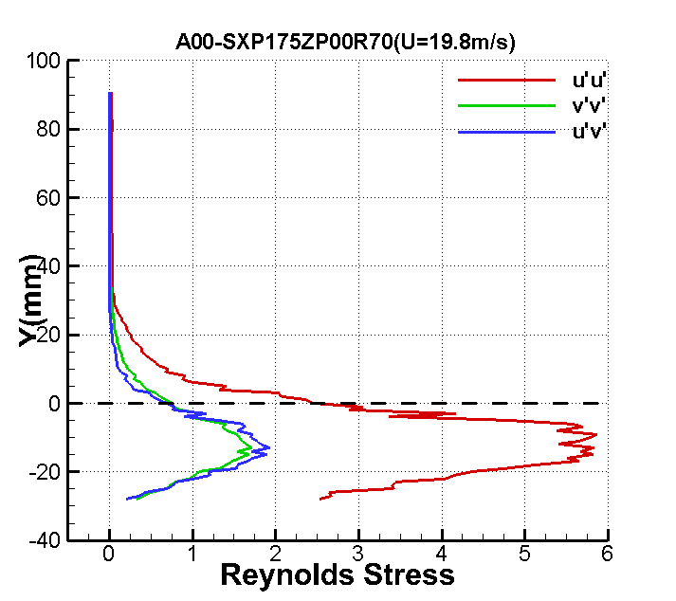

X=7h
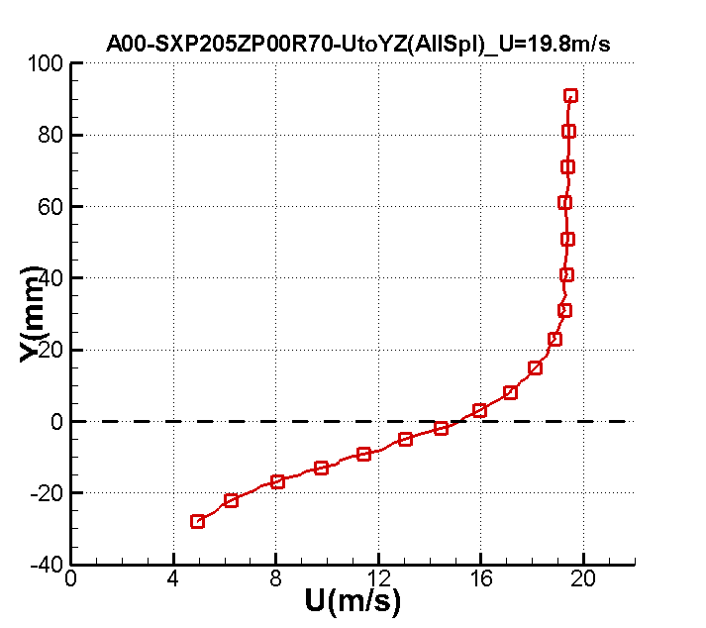
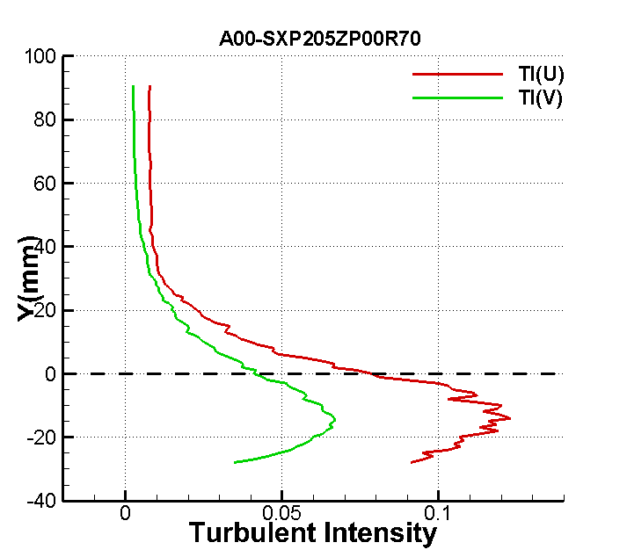
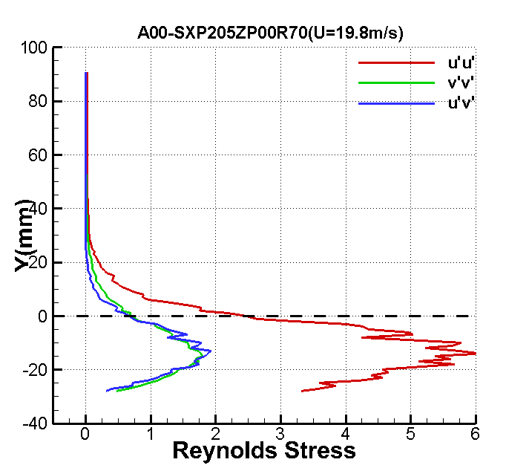

X=8h
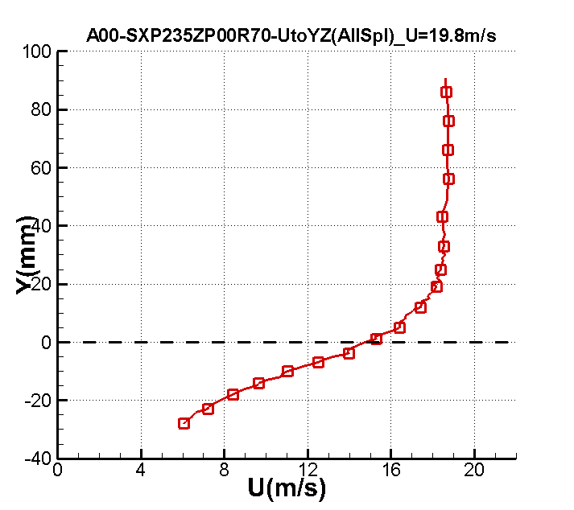
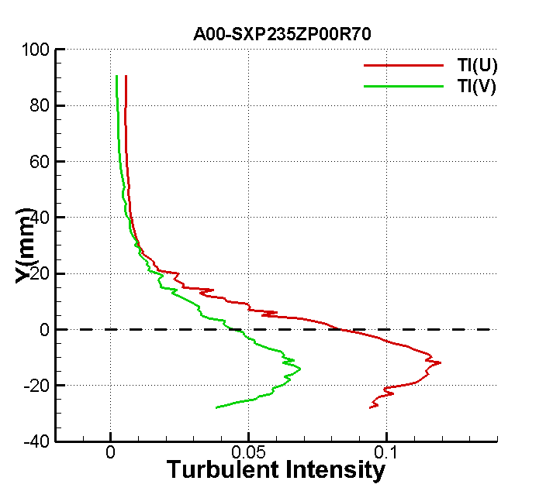
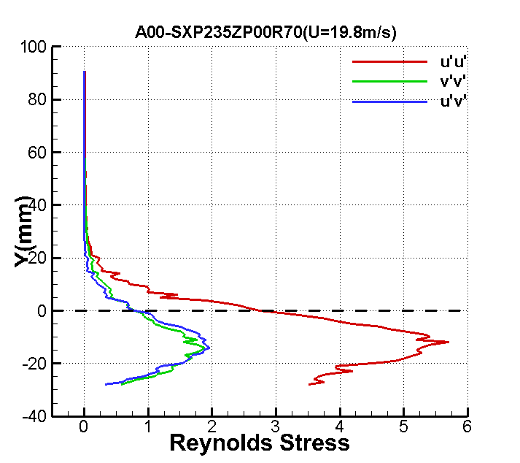

X=9h
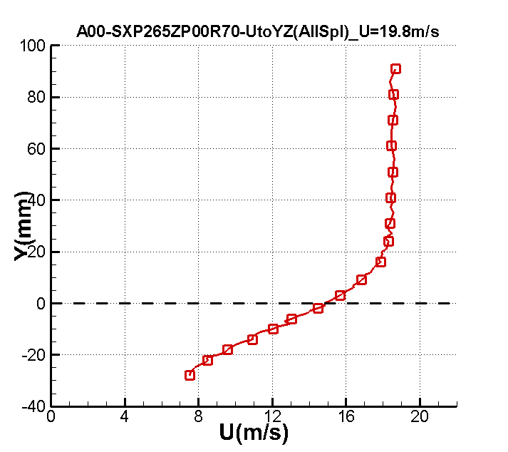
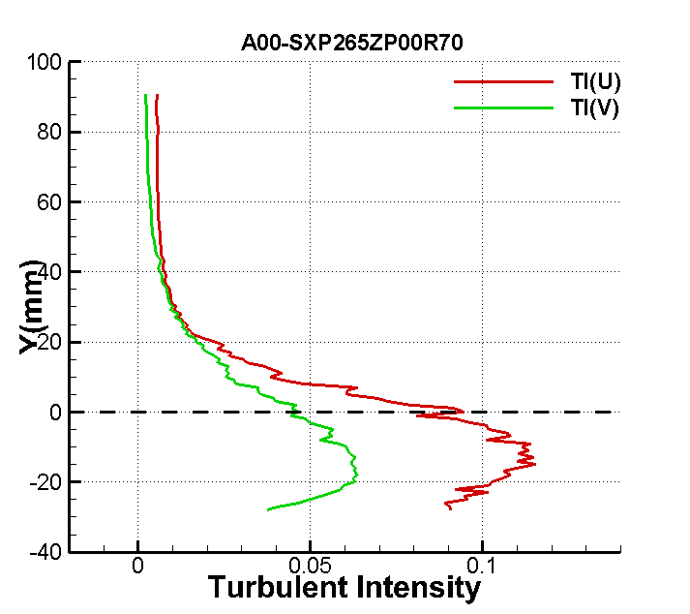
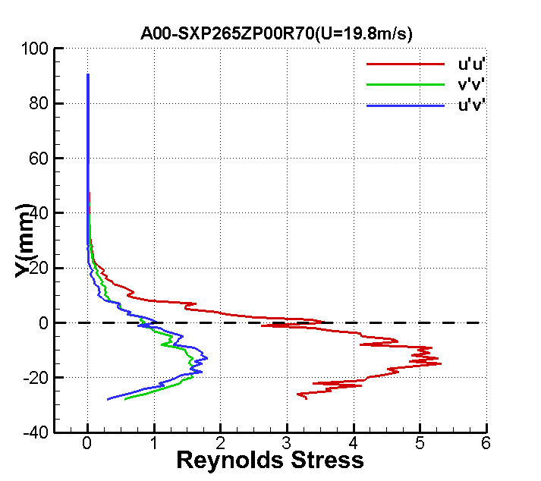

X=10h
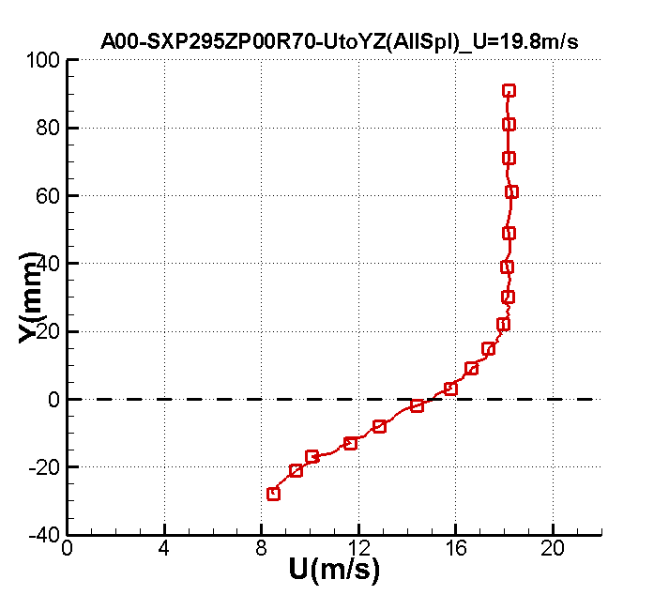
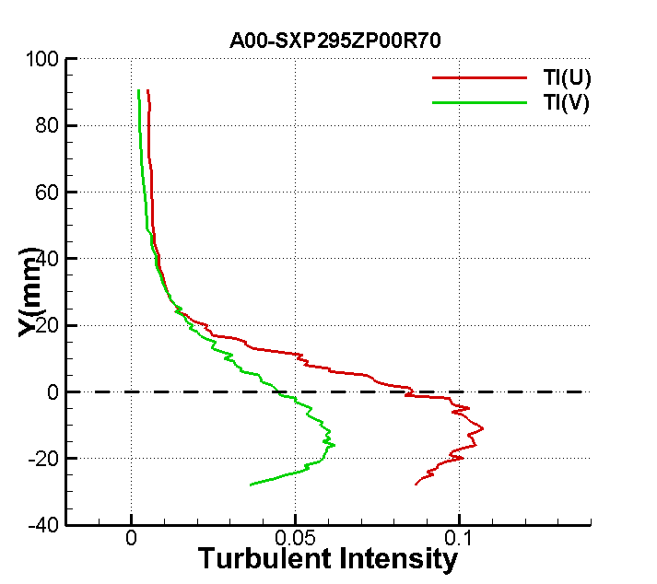
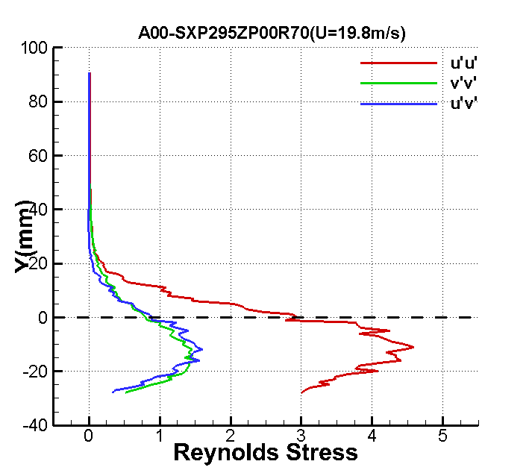

BFS_ SJ_ EXP_CF_NUAA

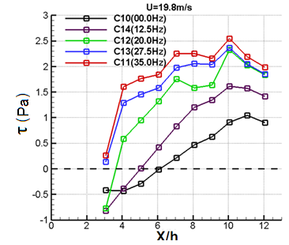

BFS_ SJ_ EXP_TSS_NUAA

X/h=1
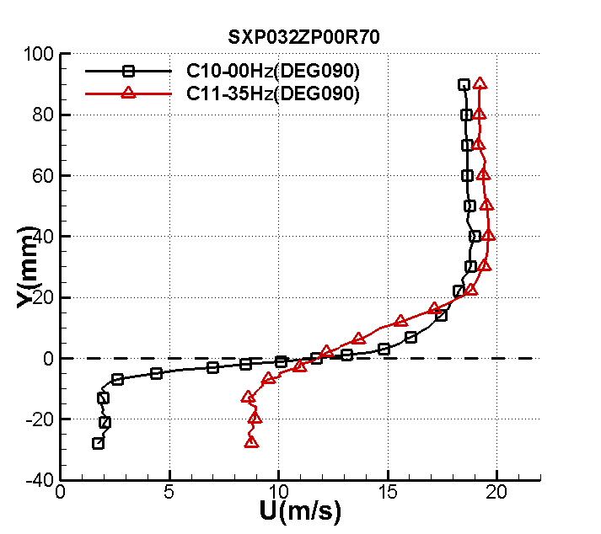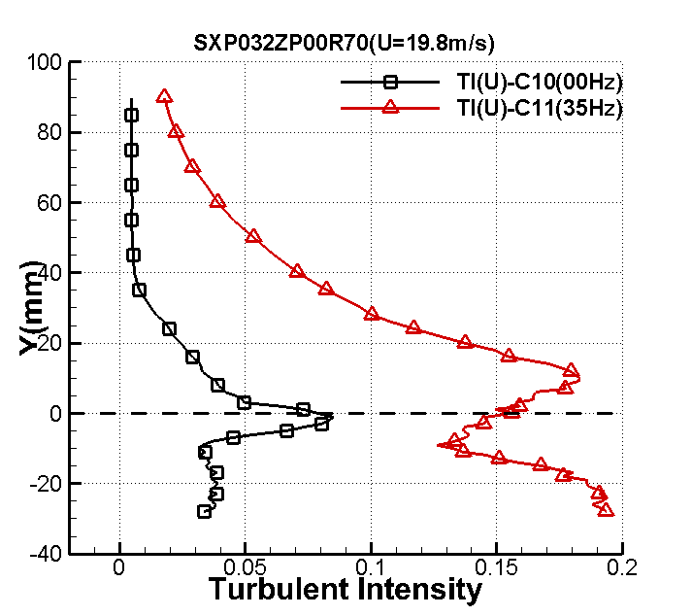
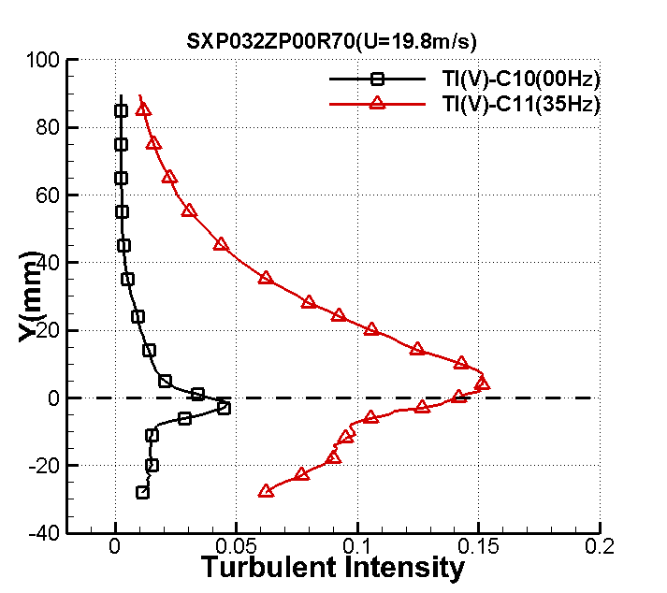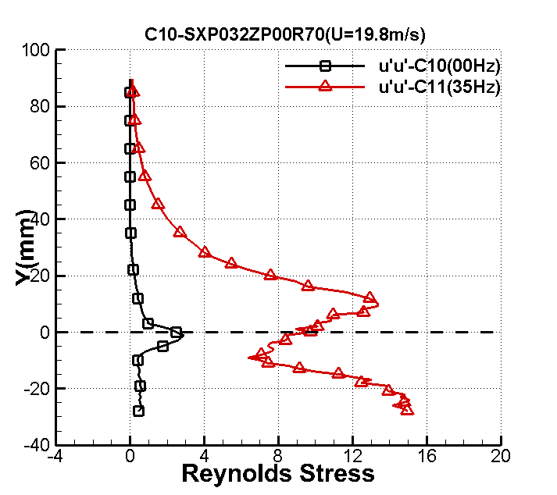

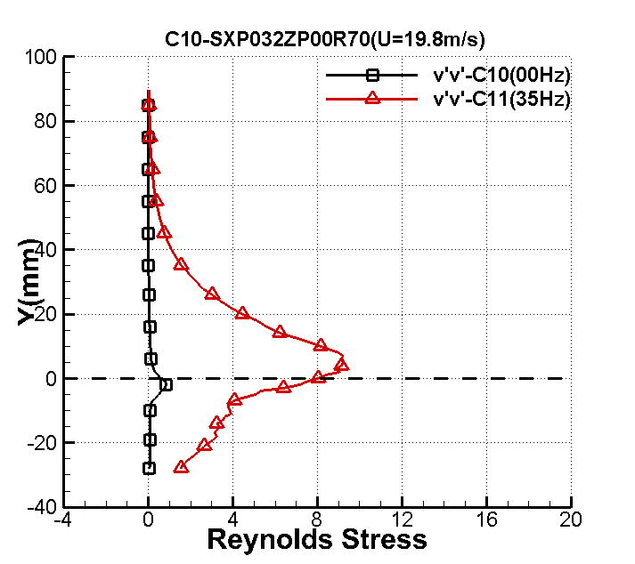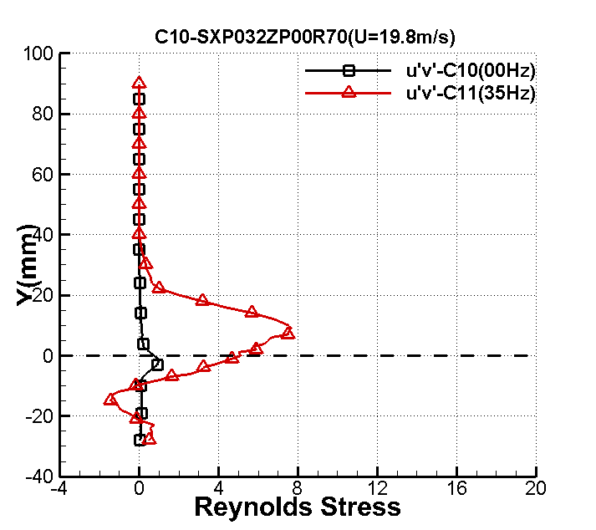

X/h=3
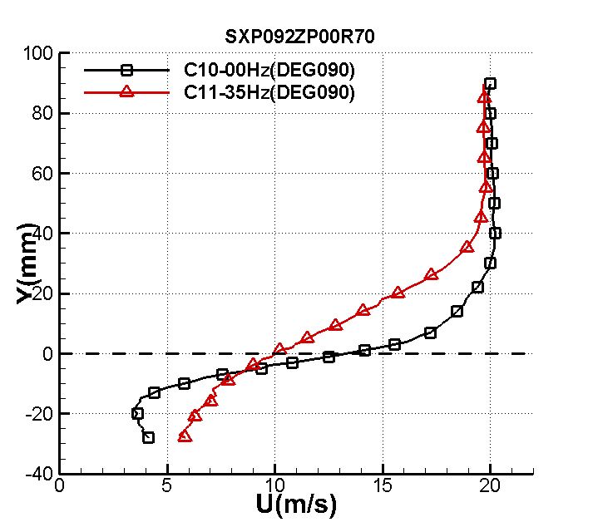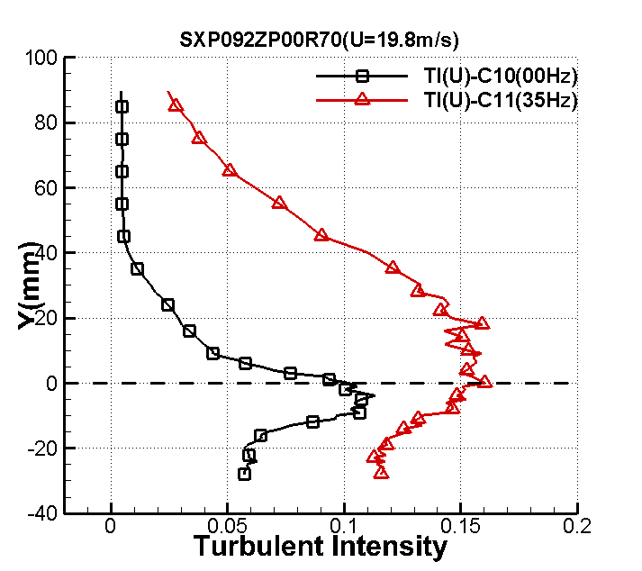

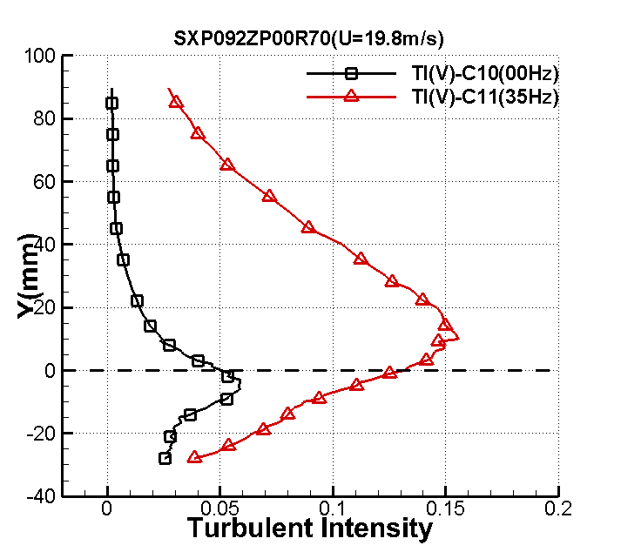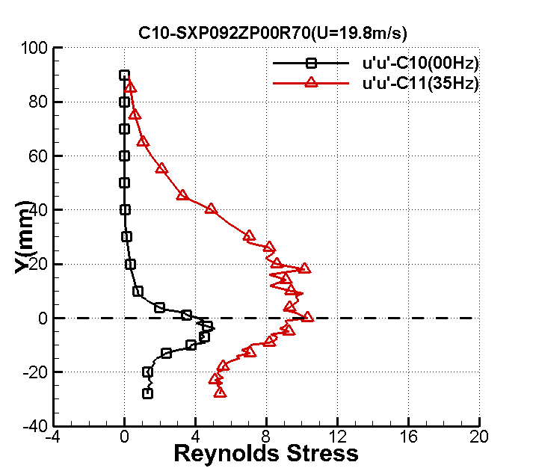

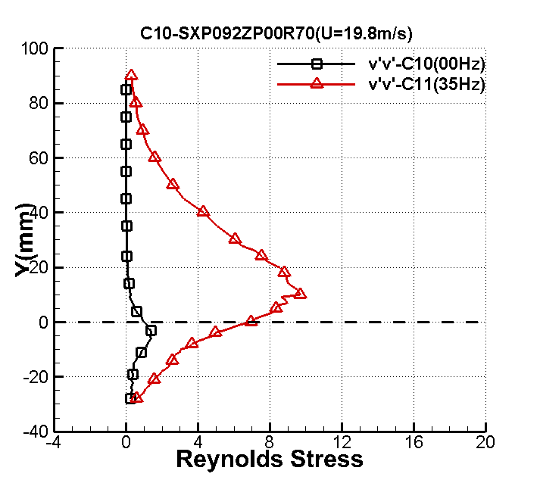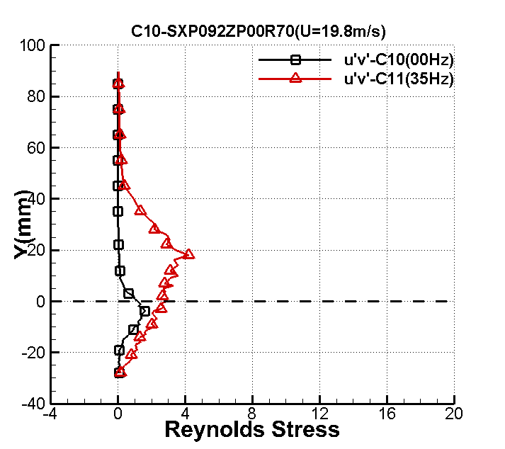

X/h=7
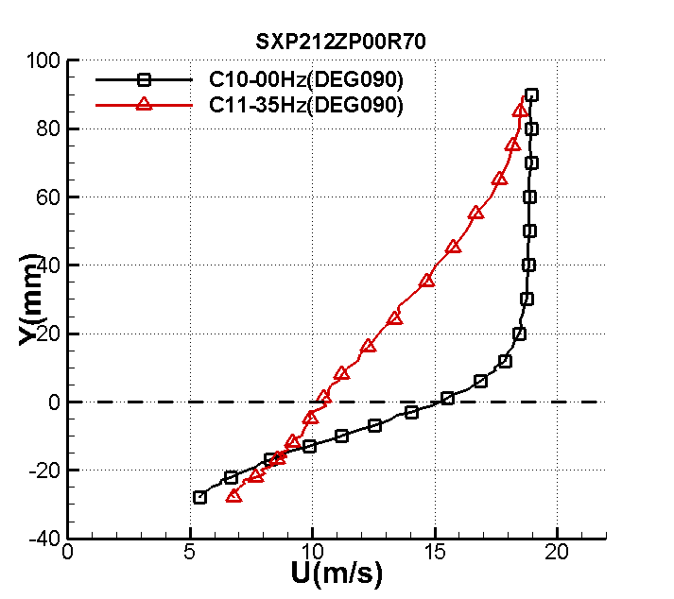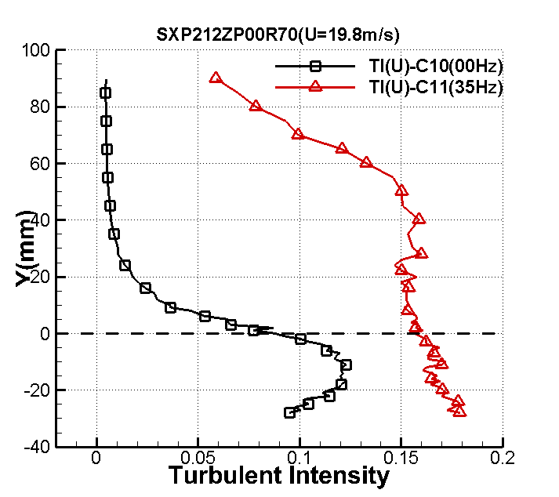
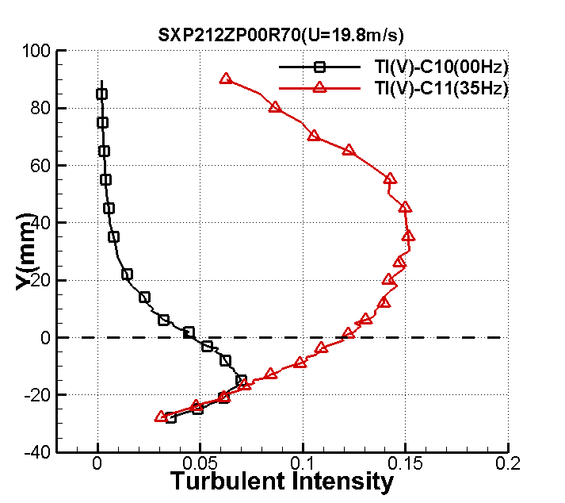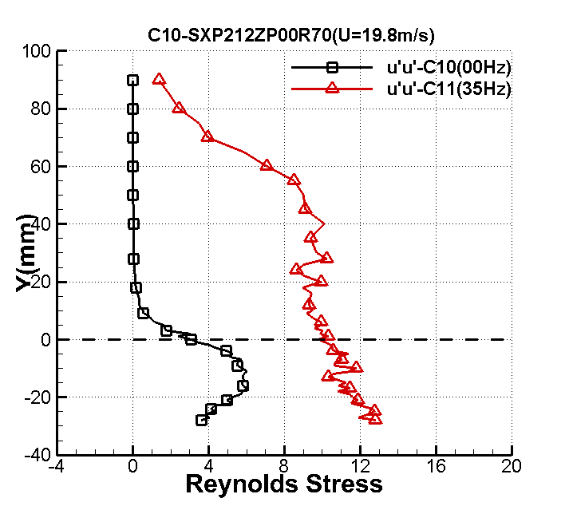
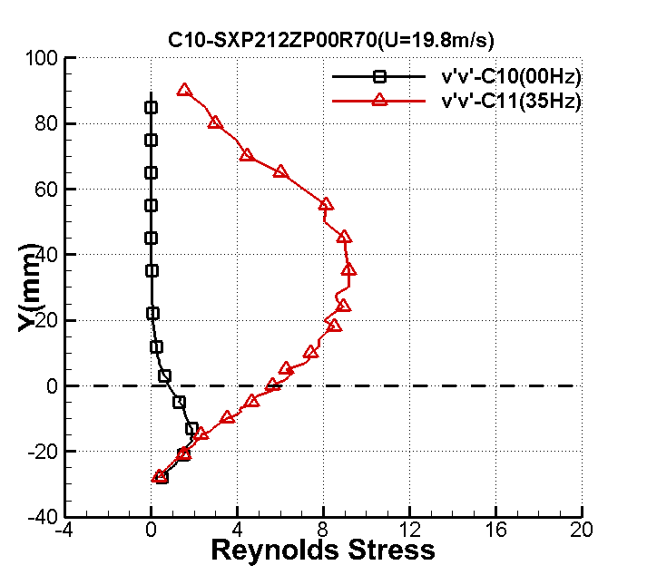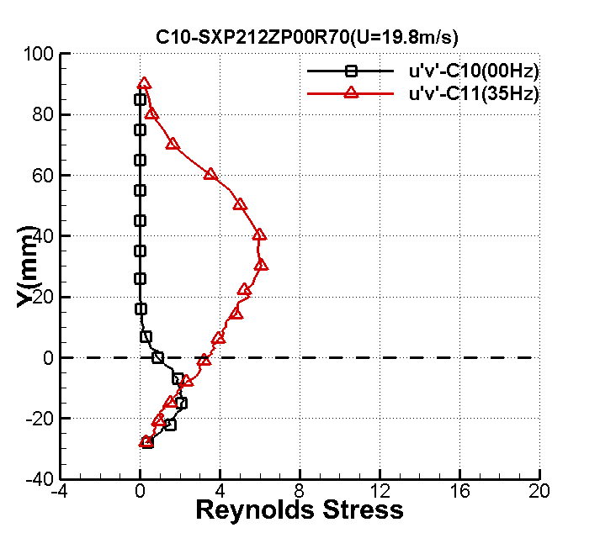

X=10h
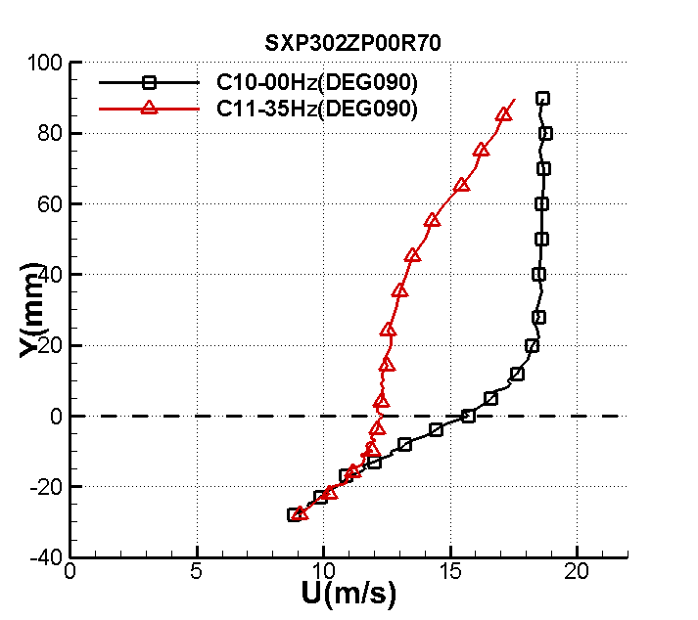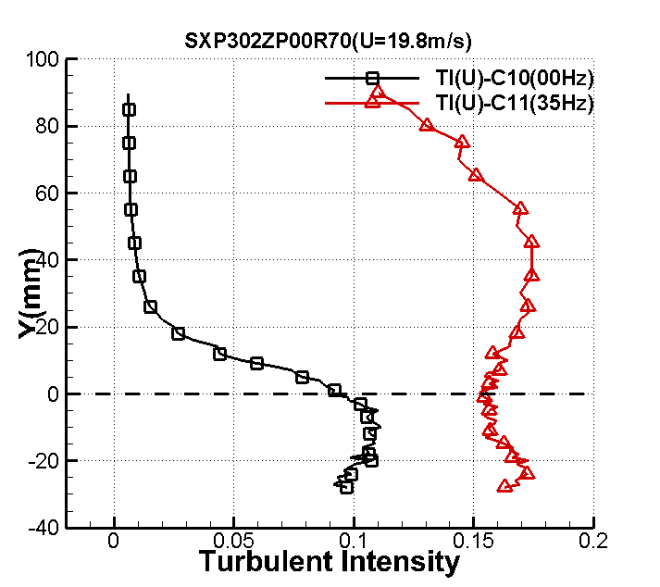
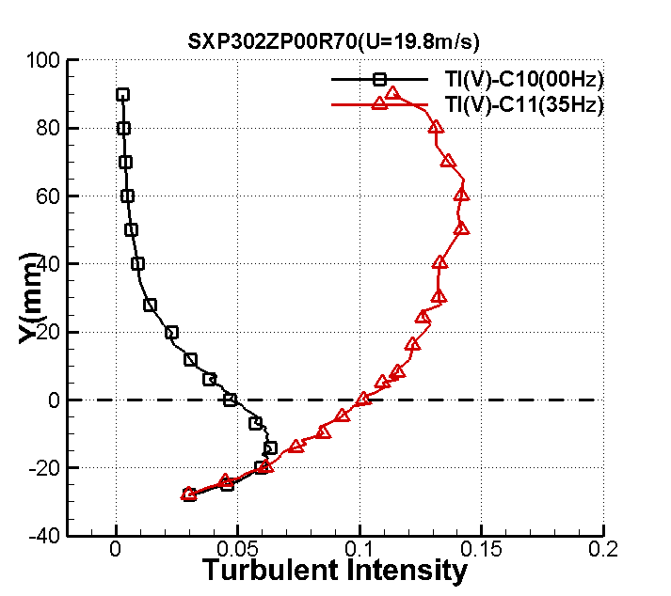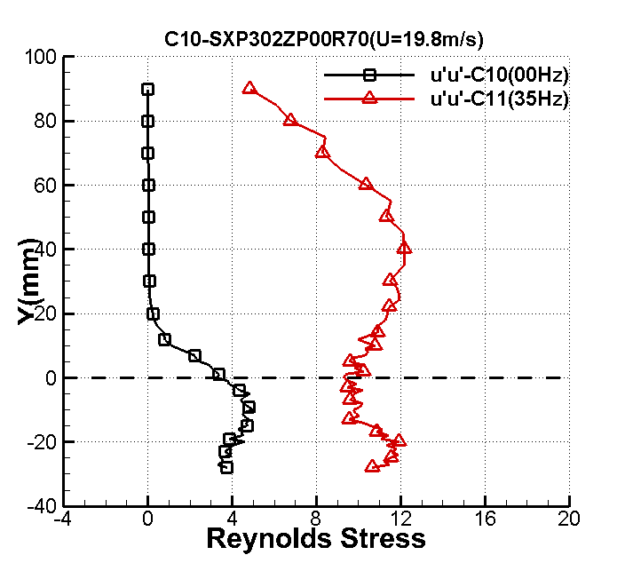
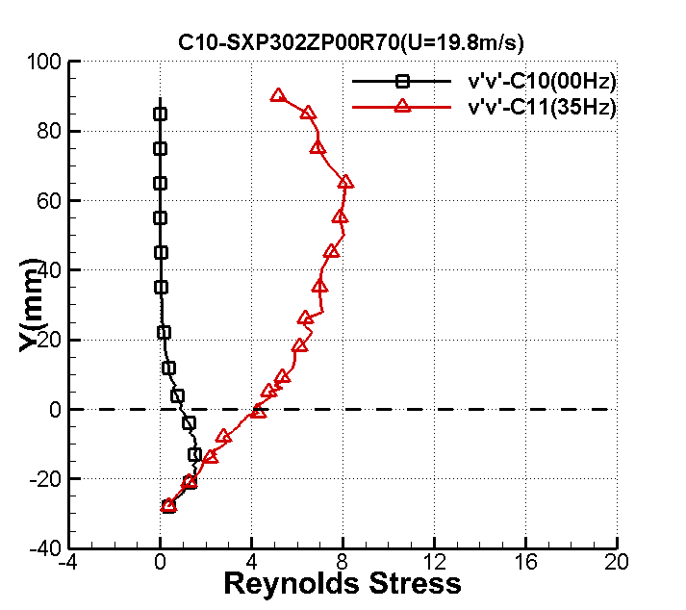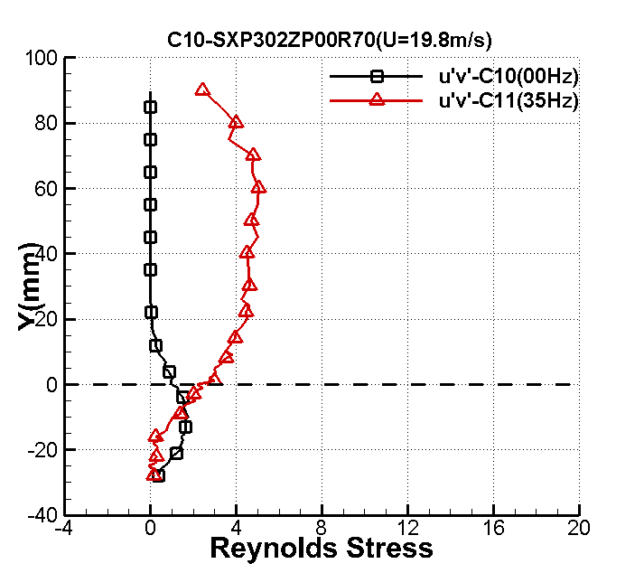

EXPERIMENTAL DATA

BFS_ BL_ EXP_MCP_NUAA
Pressure coefficient
1.0 -.180
2.0 -.188
3.0 -.189
4.0 -.154
5.0 -.011
6.0 -.023
7.0 .025
8.0 .032
9.0 .031
10.0 .028
11.0 .022
12.0 .015
13.0 .012

BFS_ BL_ EXP_MSF_NUAA
Skin friction
1.0 0.218
2.0 -0.040
3.0 -0.304
4.0 -0.508
5.0 -0.416
6.0 -0.044
7.0 0.274
8.0 0.485
9.0 0.750
10.0 0.776
11.0 1.033
12.0 0.817
13.0 0.897

BFS_ BL_ EXP_TSS_NUAA
Profile of mean velocity, turbulence intensity, and Reynolds stresses

x/h=1
y u T（u） T（v） uu vv uv
-28 1.546768 0.026719 0.010856 0.285568 0.047145 -0.000709
-27 1.561374 0.027053 0.010418 0.292745 0.043410 -0.005016
-26 1.628286 0.029995 0.010924 0.359890 0.047733 -0.017668
-25 1.765260 0.031874 0.011728 0.406369 0.055021 -0.004647
-24 1.793374 0.030425 0.012338 0.370266 0.060891 -0.005104
-23 1.666722 0.033282 0.011213 0.443088 0.050294 -0.014910
-22 1.778340 0.031729 0.011508 0.402692 0.052970 -0.024336
-21 1.718356 0.030758 0.010724 0.378412 0.045997 -0.009537
-20 1.835724 0.034710 0.011740 0.481916 0.055136 -0.043181
-19 1.908035 0.031203 0.011128 0.389446 0.049534 -0.039305
-18 1.805102 0.033080 0.012231 0.437707 0.059843 -0.050984
-17 1.811734 0.031365 0.011866 0.393493 0.056318 -0.047915
-16 1.900317 0.031350 0.011623 0.393135 0.054038 -0.058331
-15 1.877537 0.035538 0.012770 0.505173 0.065226 -0.060357
-14 1.858204 0.034570 0.011997 0.478044 0.057570 -0.057499
-13 1.955382 0.031652 0.012969 0.400732 0.067278 -0.078645
-12 1.862972 0.030058 0.011813 0.361403 0.055823 -0.062242
-11 1.818255 0.031951 0.012287 0.408344 0.060392 -0.074517
-10 1.891201 0.032737 0.012523 0.428693 0.062729 -0.088415
-9 1.941492 0.031937 0.013460 0.407977 0.072474 -0.073463
-8 1.829775 0.031731 0.012856 0.402750 0.066114 -0.059135
-7 1.835821 0.028426 0.012949 0.323205 0.067075 -0.045506
-6 2.124623 0.034099 0.016138 0.465085 0.104175 -0.056615
-5 2.626808 0.041239 0.022281 0.680262 0.198585 -0.152463
-4 3.705980 0.056370 0.031676 1.271045 0.401357 -0.347940
-3 5.246406 0.069046 0.040100 1.906922 0.643202 -0.608251
-2 7.375533 0.073519 0.045604 2.162032 0.831904 -0.777864
-1 9.361581 0.076322 0.045216 2.330018 0.817808 -0.781573
0 11.326505 0.074805 0.040487 2.238309 0.655672 -0.645154
1 13.008885 0.063889 0.031894 1.632737 0.406888 -0.373167
2 13.920048 0.056446 0.026832 1.274476 0.287985 -0.244984
3 14.469229 0.051325 0.023412 1.053707 0.219245 -0.199047
4 14.755242 0.052474 0.022375 1.101425 0.200264 -0.203761
5 15.112646 0.047397 0.021694 0.898596 0.188248 -0.195927
6 15.431596 0.049405 0.019924 0.976325 0.158790 -0.185478
7 15.759193 0.047399 0.019764 0.898648 0.156240 -0.178668
8 15.922691 0.046543 0.019481 0.866502 0.151805 -0.173469
9 16.261740 0.044656 0.018812 0.797661 0.141555 -0.163134
10 16.415917 0.045128 0.019424 0.814616 0.150923 -0.180776
11 16.806207 0.044001 0.018419 0.774427 0.135700 -0.169690
12 16.777616 0.042241 0.018008 0.713717 0.129716 -0.156020
13 17.055974 0.041583 0.018085 0.691644 0.130823 -0.150667
14 17.192547 0.039673 0.017467 0.629568 0.122045 -0.133635
15 17.380397 0.040523 0.017550 0.656836 0.123197 -0.143985
16 17.598949 0.038516 0.016935 0.593394 0.114714 -0.130950
17 17.802098 0.035965 0.016358 0.517396 0.107038 -0.118345
18 17.879073 0.037738 0.016048 0.569673 0.103018 -0.122477
19 17.945729 0.034601 0.015460 0.478887 0.095608 -0.100760
20 18.185973 0.035553 0.015807 0.505604 0.099939 -0.114132
21 18.241020 0.032962 0.015008 0.434608 0.090093 -0.095077
22 18.448711 0.031800 0.014025 0.404494 0.078680 -0.080193
23 18.584044 0.030947 0.013535 0.383083 0.073280 -0.074799
24 18.811622 0.029956 0.013300 0.358934 0.070754 -0.076531
25 18.927644 0.027893 0.012367 0.311213 0.061176 -0.058061
26 18.967689 0.025741 0.011801 0.265031 0.055709 -0.053007
27 19.122530 0.024403 0.011075 0.238199 0.049065 -0.043462
28 19.157112 0.023945 0.010994 0.229338 0.048350 -0.044686
29 19.254690 0.022947 0.010465 0.210626 0.043808 -0.037707
30 19.323824 0.020824 0.009751 0.173457 0.038030 -0.029963
31 19.400059 0.019838 0.009479 0.157414 0.035939 -0.028221
33 19.642599 0.016474 0.008235 0.108563 0.027123 -0.016061
35 19.655533 0.012825 0.007038 0.065790 0.019812 -0.008747
37 19.740633 0.009836 0.006129 0.038697 0.015025 -0.002815
39 19.676174 0.007505 0.005295 0.022528 0.011217 -0.000631
41 19.758959 0.006161 0.004678 0.015184 0.008752 0.0006010
43 19.763398 0.005679 0.004098 0.012901 0.006716 0.001050
45 19.652269 0.005403 0.003755 0.011679 0.005641 0.001844
47 19.762713 0.004788 0.003345 0.009170 0.004476 0.001548
49 19.808711 0.004747 0.003046 0.009013 0.003712 0.001700
51 19.792036 0.004413 0.002947 0.007788 0.003473 0.001446
56 19.741378 0.004539 0.002476 0.008242 0.002451 0.001546
61 19.647374 0.004180 0.002188 0.006990 0.001915 0.001340
66 19.703300 0.004217 0.002078 0.007112 0.001728 0.001439
71 19.673443 0.004293 0.002028 0.007373 0.001645 0.001550
76 19.587975 0.004252 0.002010 0.007232 0.001616 0.001544
81 19.556731 0.004090 0.001943 0.006691 0.001510 0.001543
86 19.508267 0.004152 0.001902 0.006895 0.001447 0.001302
91 19.528817 0.004037 0.001921 0.006519 0.001477 0.001343
x/h=2
-28 2.448970 0.043835 0.015600 0.768616 0.097340 -0.056572
-27 2.323112 0.040686 0.015575 0.662139 0.097038 -0.054413
-26 2.447255 0.041635 0.016025 0.693388 0.102715 -0.049052
-25 2.402093 0.041917 0.016102 0.702803 0.103714 -0.048015
-24 2.417352 0.043904 0.017045 0.771029 0.116210 -0.041378
-23 2.533528 0.043141 0.017547 0.744463 0.123158 -0.091235
-22 2.471454 0.043633 0.017106 0.761522 0.117044 -0.074751
-21 2.230013 0.039734 0.016259 0.631501 0.105741 -0.046063
-20 2.333648 0.042722 0.017831 0.730076 0.127182 -0.074022
-19 2.268536 0.040987 0.016209 0.671980 0.105088 -0.070504
-18 2.162298 0.038578 0.015385 0.595299 0.094681 -0.058392
-17 2.245813 0.039402 0.016565 0.621015 0.109760 -0.065867
-16 2.029998 0.035564 0.015377 0.505928 0.094577 -0.053667
-15 2.158871 0.038956 0.017200 0.607040 0.118343 -0.073024
-14 2.105245 0.037510 0.016874 0.562802 0.113890 -0.060885
-13 2.345948 0.040794 0.019046 0.665656 0.145102 -0.089976
-12 2.430815 0.041327 0.020810 0.683179 0.173228 -0.125287
-11 2.699019 0.053553 0.024521 1.147191 0.240503 -0.225436
-10 2.993555 0.053328 0.027456 1.137532 0.301523 -0.274608
-9 3.377770 0.060262 0.030608 1.452607 0.374740 -0.365258
-8 4.195532 0.074479 0.036763 2.218838 0.540597 -0.593019
-7 4.510977 0.071988 0.038257 2.072898 0.585451 -0.575372
-6 5.787002 0.086963 0.045650 3.024999 0.833583 -0.930544
-5 6.744192 0.085391 0.046030 2.916669 0.847520 -0.898462
-4 7.535108 0.091484 0.048833 3.347700 0.953873 -1.038644
-3 8.745468 0.090011 0.049841 3.240797 0.993643 -0.986454
-2 9.702377 0.097855 0.049799 3.830272 0.991965 -1.138358
-1 10.915617 0.092250 0.045461 3.403993 0.826685 -0.923238
0 12.159997 0.080324 0.041117 2.580800 0.676248 -0.757204
1 12.950073 0.077076 0.038393 2.376302 0.589602 -0.637512
2 13.885953 0.069933 0.033722 1.956271 0.454858 -0.448410
3 14.348904 0.065778 0.031623 1.730703 0.399996 -0.375259
4 14.891503 0.054706 0.027131 1.197117 0.294444 -0.245898
5 15.304461 0.052914 0.026946 1.119951 0.290444 -0.265013
6 15.780743 0.049237 0.023918 0.969709 0.228821 -0.181931
7 15.830682 0.047334 0.023362 0.896212 0.218313 -0.175724
8 16.163377 0.045530 0.022356 0.829186 0.199924 -0.173246
9 16.242643 0.044290 0.020995 0.784632 0.176311 -0.159734
10 16.515031 0.042892 0.019935 0.735904 0.158961 -0.147178
11 16.715710 0.042452 0.019028 0.720862 0.144829 -0.141545
12 16.794451 0.041112 0.019140 0.676079 0.146532 -0.143922
13 17.102955 0.039934 0.018315 0.637888 0.134175 -0.128598
14 17.253119 0.039679 0.018142 0.629763 0.131647 -0.136138
15 17.470069 0.036719 0.016833 0.539327 0.113336 -0.112163
16 17.586507 0.036505 0.016599 0.533040 0.110216 -0.106708
17 17.668312 0.035958 0.016748 0.517197 0.112203 -0.115154
18 17.961036 0.034090 0.015465 0.464844 0.095668 -0.101048
19 18.039387 0.034348 0.015327 0.471920 0.093972 -0.099737
20 18.196613 0.033316 0.014754 0.443991 0.087074 -0.091529
21 18.256989 0.030429 0.014099 0.370365 0.079517 -0.077491
22 18.354546 0.030769 0.014044 0.378699 0.078891 -0.076602
23 18.524242 0.030065 0.013099 0.361570 0.068637 -0.068851
24 18.734107 0.027858 0.012710 0.310420 0.064620 -0.057670
25 18.753553 0.026743 0.011990 0.286066 0.057505 -0.050660
26 18.820268 0.024320 0.011784 0.236578 0.055545 -0.049119
27 19.047252 0.022806 0.010734 0.208039 0.046086 -0.035613
28 19.113736 0.021591 0.010542 0.186466 0.044449 -0.034740
29 19.187496 0.022077 0.010082 0.194951 0.040659 -0.032578
30 19.333146 0.018966 0.009309 0.143876 0.034667 -0.024478
31 19.421488 0.018556 0.008855 0.137731 0.031361 -0.022848
33 19.555413 0.013164 0.007571 0.069318 0.022928 -0.009545
35 19.591335 0.011753 0.006964 0.055250 0.019399 -0.006907
37 19.623909 0.008547 0.006053 0.029224 0.014655 -0.001592
39 19.635123 0.006600 0.005039 0.017423 0.010158 -0.000461
41 19.588663 0.005921 0.004557 0.014024 0.008305 0.000682
43 19.651153 0.005009 0.003980 0.010038 0.006336 0.001000
45 19.579921 0.004893 0.003695 0.009576 0.005462 0.001181
47 19.609506 0.004634 0.003432 0.008589 0.004711 0.001599
49 19.580070 0.004758 0.003081 0.009055 0.003797 0.001964
51 19.591128 0.004529 0.002967 0.008206 0.003520 0.001775
56 19.533875 0.004592 0.002636 0.008433 0.002779 0.002006
61 19.551092 0.004294 0.002344 0.007377 0.002198 0.001605
66 19.449949 0.004389 0.002171 0.007704 0.001885 0.001902
71 19.427192 0.004217 0.002121 0.007113 0.001800 0.001805
76 19.453237 0.004166 0.002081 0.006943 0.001733 0.001622
81 19.368856 0.004001 0.001941 0.006404 0.001507 0.001463
86 19.404386 0.003999 0.001938 0.006398 0.001502 0.001531
91 19.305875 0.004281 0.002062 0.007330 0.001701 0.001845
x/h=3
-28 3.386572 0.048481 0.021252 0.940144 0.180653 0.003299
-27 3.238413 0.049775 0.021368 0.991003 0.182644 -0.015268
-26 3.210371 0.050317 0.024142 1.012727 0.233134 -0.004468
-25 3.175700 0.050476 0.023529 1.019147 0.221453 -0.039408
-24 3.141962 0.049637 0.023291 0.985517 0.216980 -0.040949
-23 2.936089 0.047552 0.023127 0.904477 0.213950 -0.007264
-22 3.094960 0.049561 0.024184 0.982504 0.233941 -0.015779
-21 2.885805 0.048086 0.023169 0.924891 0.214724 -0.004683
-20 3.043579 0.049278 0.024565 0.971326 0.241377 -0.011667
-19 3.050103 0.052422 0.025265 1.099237 0.255338 -0.086200
-18 3.030030 0.048371 0.026171 0.935913 0.273978 -0.068225
-17 3.069778 0.052934 0.024344 1.120814 0.237048 -0.136469
-16 3.137540 0.054865 0.028123 1.204057 0.316351 -0.253579
-15 3.446151 0.060573 0.030514 1.467658 0.372442 -0.337351
-14 3.785377 0.066257 0.034371 1.755988 0.472548 -0.452490
-13 3.951234 0.075048 0.035739 2.252897 0.510917 -0.506793
-12 4.345093 0.077507 0.038460 2.402905 0.591656 -0.641093
-11 5.231331 0.082557 0.043690 2.726259 0.763511 -0.820861
-10 5.584453 0.087468 0.045826 3.060277 0.839999 -0.899998
-9 6.176361 0.092707 0.050017 3.437831 1.000681 -1.038537
-8 6.904223 0.098057 0.051269 3.846091 1.051389 -1.144853
-7 7.819338 0.094154 0.050770 3.545977 1.031034 -1.040964
-6 8.416866 0.098092 0.053302 3.848778 1.136439 -1.228516
-5 9.299771 0.099316 0.053053 3.945441 1.125832 -1.188631
-4 10.219813 0.101625 0.051777 4.131039 1.072328 -1.237337
-3 11.006040 0.097243 0.049979 3.782507 0.999161 -1.093592
-2 11.921137 0.090447 0.045840 3.272233 0.840526 -0.905209
-1 12.771360 0.084028 0.042641 2.824309 0.727299 -0.789251
0 13.146689 0.085165 0.043520 2.901226 0.757610 -0.801770
1 13.797548 0.077222 0.039424 2.385274 0.621710 -0.620069
2 14.386603 0.070852 0.035361 2.008015 0.500167 -0.477882
3 14.851155 0.062943 0.032405 1.584710 0.420038 -0.360666
4 15.308920 0.059130 0.029176 1.398547 0.340489 -0.292280
5 15.645656 0.050990 0.026931 1.040004 0.290121 -0.223411
6 15.860753 0.049697 0.027023 0.987918 0.292098 -0.219485
7 16.047444 0.047676 0.025287 0.909196 0.255769 -0.196599
8 16.301131 0.044593 0.023660 0.795406 0.223924 -0.173561
9 16.527983 0.041589 0.022585 0.691861 0.204028 -0.140917
10 16.677912 0.042165 0.021272 0.711147 0.180993 -0.143857
11 16.884030 0.041221 0.020347 0.679664 0.165593 -0.139720
12 17.031260 0.040187 0.019319 0.645992 0.149287 -0.137623
13 17.256202 0.036957 0.018767 0.546323 0.140883 -0.113322
14 17.370530 0.037735 0.018101 0.569580 0.131052 -0.117441
15 17.352570 0.036097 0.017506 0.521205 0.122581 -0.106546
16 17.604091 0.035555 0.017395 0.505660 0.121028 -0.103300
17 17.833154 0.034173 0.015672 0.467128 0.098248 -0.088273
18 17.844807 0.031687 0.015393 0.401622 0.094777 -0.079250
19 18.016713 0.031917 0.015150 0.407468 0.091805 -0.084404
20 18.004348 0.029945 0.014285 0.358690 0.081622 -0.075959
21 18.247154 0.030147 0.013845 0.363533 0.076669 -0.064275
22 18.387245 0.028342 0.013358 0.321299 0.071373 -0.059698
23 18.483161 0.026582 0.012239 0.282649 0.059917 -0.051809
24 18.569906 0.025249 0.011491 0.255013 0.052817 -0.041657
25 18.671701 0.023791 0.011181 0.226406 0.050002 -0.035970
26 18.789107 0.023497 0.010985 0.220842 0.048265 -0.040237
27 18.888510 0.020329 0.010025 0.165306 0.040197 -0.023558
28 19.001348 0.019765 0.009888 0.156270 0.039105 -0.026315
29 19.022040 0.017817 0.008964 0.126973 0.032141 -0.018060
30 19.031032 0.016036 0.008633 0.102858 0.029813 -0.012678
31 19.091294 0.014411 0.008057 0.083069 0.025964 -0.009368
33 19.261819 0.011798 0.007171 0.055678 0.020568 -0.004001
35 19.377127 0.009276 0.006504 0.034419 0.016920 -0.002751
37 19.292343 0.007318 0.005433 0.021419 0.011809 0.0007840
39 19.255933 0.005964 0.004778 0.014226 0.009132 0.0012700
41 19.246553 0.005452 0.004250 0.011890 0.007227 0.0016520
43 19.240234 0.005346 0.004043 0.011431 0.006538 0.0020710
45 19.289446 0.004951 0.003668 0.009804 0.005383 0.002070
47 19.264064 0.004796 0.003348 0.009200 0.004483 0.002189
49 19.269356 0.004962 0.003134 0.009848 0.003929 0.002459
51 19.044937 0.004480 0.002925 0.008029 0.003423 0.001933
56 19.142445 0.004355 0.002512 0.007586 0.002524 0.001909
61 19.165061 0.004412 0.002391 0.007788 0.002288 0.001994
66 19.150396 0.004603 0.002283 0.008476 0.002084 0.002122
71 19.064480 0.004456 0.002245 0.007944 0.002016 0.002202
76 19.034704 0.004361 0.002149 0.007608 0.001847 0.002009
81 19.014866 0.004214 0.002047 0.007102 0.001677 0.001652
86 19.035879 0.004285 0.002056 0.007345 0.001691 0.001890
91 19.045868 0.004123 0.002077 0.006798 0.001726 0.001764 x/h=4
-283.966952 0.057291 0.026856 1.312899 0.288493-0.022673
-27 3.856921 0.057812 0.027936 1.336892 0.312170 -0.047891
-26 3.768498 0.058614 0.026948 1.374263 0.290470 -0.027350
-25 3.788346 0.055257 0.028603 1.221346 0.327257 -0.003326
-24 3.714152 0.054403 0.030001 1.183885 0.360024 -0.081128
-23 3.800196 0.059094 0.031637 1.396828 0.400369 -0.101632
-22 3.777145 0.062182 0.033762 1.546623 0.455960 -0.148212
-21 3.849921 0.061677 0.032672 1.521643 0.426975 -0.195418
-20 3.937404 0.069299 0.034023 1.920960 0.463022 -0.244597
-19 4.161338 0.073784 0.039445 2.177604 0.622348 -0.462263
-18 4.403819 0.078327 0.041760 2.454044 0.697571 -0.567355
-17 4.315162 0.076549 0.039479 2.343872 0.623450 -0.512589
-16 4.640225 0.087949 0.042996 3.094017 0.739461 -0.819254
-15 5.127875 0.094556 0.048373 3.576309 0.935990 -1.080361
-14 5.464240 0.100103 0.050306 4.008219 1.012286 -1.193949
-13 6.110087 0.101489 0.053686 4.120007 1.152886 -1.282646
-12 6.707890 0.109032 0.056384 4.755204 1.271642 -1.426142
-11 7.287423 0.107467 0.058713 4.619630 1.378884 -1.515827
-10 7.830192 0.110543 0.059340 4.887909 1.408492 -1.582238
-9 8.452788 0.113504 0.061171 5.153257 1.496773 -1.668171
-8 8.914920 0.114690 0.059178 5.261507 1.400827 -1.588010
-7 9.680870 0.109739 0.059790 4.817016 1.429952 -1.579935
-6 10.635321 0.107650 0.055616 4.635410 1.237269 -1.344194
-5 11.294254 0.110815 0.056811 4.911961 1.290979 -1.382218
-4 12.281891 0.101865 0.052890 4.150615 1.118932 -1.191962
-3 12.710364 0.103460 0.050806 4.281579 1.032498 -1.168703
-2 13.260425 0.094586 0.050389 3.578584 1.015618 -0.995238
-1 13.954233 0.092429 0.045160 3.417276 0.815783 -0.836145
0 14.707805 0.080423 0.040542 2.587139 0.657471 -0.627600
1 14.857326 0.077841 0.041104 2.423710 0.675815 -0.596560
2 15.384577 0.070048 0.037651 1.962669 0.567028 -0.480853
3 15.920191 0.067619 0.034738 1.828942 0.482688 -0.400315
4 16.216929 0.060029 0.032820 1.441393 0.430856 -0.302830
5 16.538716 0.056344 0.029956 1.269853 0.358937 -0.272039
6 16.778602 0.054194 0.030512 1.174783 0.372387 -0.266485
7 16.981742 0.046972 0.027039 0.882538 0.292452 -0.169692
8 17.230742 0.045044 0.025526 0.811592 0.260627 -0.163997
9 17.501513 0.043119 0.023455 0.743711 0.220050 -0.140199
10 17.632241 0.042767 0.021885 0.731619 0.191573 -0.119871
11 17.876734 0.039513 0.020967 0.624511 0.175844 -0.112918
12 17.984738 0.038738 0.019448 0.600268 0.151283 -0.101319
13 18.125870 0.037350 0.019894 0.558004 0.158310 -0.093920
14 18.213592 0.036311 0.018298 0.527400 0.133924 -0.093964
15 18.514584 0.035179 0.017784 0.495029 0.126507 -0.091303
16 18.587815 0.033935 0.017091 0.460625 0.116845 -0.090526
17 18.735386 0.033291 0.015904 0.443313 0.101178 -0.075641
18 18.791890 0.031279 0.015643 0.391341 0.097884 -0.066725
19 18.935005 0.030185 0.015449 0.364452 0.095462 -0.069650
20 19.190257 0.029745 0.014553 0.353913 0.084714 -0.060873
21 19.246009 0.027641 0.013363 0.305619 0.071424 -0.050925
22 19.331022 0.025558 0.012750 0.261282 0.065020 -0.039455
23 19.395379 0.025229 0.011996 0.254601 0.057566 -0.036349
24 19.496074 0.022220 0.011382 0.197495 0.051818 -0.028652
25 19.549209 0.022323 0.011005 0.199325 0.048443 -0.028317
26 19.659773 0.020394 0.010515 0.166370 0.044230 -0.023521
27 19.756101 0.018192 0.009786 0.132378 0.038304 -0.017426
28 19.888771 0.015927 0.009263 0.101472 0.034325 -0.013141
29 19.799842 0.015055 0.008742 0.090660 0.030571 -0.008912
30 19.848905 0.013669 0.007968 0.074733 0.025394 -0.006611
31 19.946715 0.012084 0.007628 0.058408 0.023273 -0.004834
33 20.055601 0.010306 0.006893 0.042487 0.019007 -0.003970
35 20.066810 0.007771 0.005887 0.024156 0.013863 0.000310
37 20.019711 0.006757 0.005202 0.018261 0.010825 0.001003
39 20.095370 0.006261 0.004882 0.015681 0.009533 0.001063
41 20.039005 0.005607 0.004139 0.012573 0.006853 0.001685
43 20.169786 0.005514 0.003947 0.012161 0.006232 0.001968
45 20.126981 0.005284 0.003556 0.011167 0.005057 0.001423
47 20.091308 0.005228 0.003373 0.010934 0.004552 0.001721
49 20.050905 0.004833 0.003102 0.009344 0.003849 0.001443
51 20.003095 0.005039 0.002973 0.010156 0.003537 0.001617
56 20.126681 0.004559 0.002492 0.008312 0.002484 0.001191
61 19.930165 0.004173 0.002277 0.006965 0.002074 0.001146
66 20.010453 0.004278 0.002128 0.007320 0.001811 0.001228
71 19.894243 0.004330 0.002069 0.007500 0.001712 0.001258
76 19.932366 0.004772 0.002051 0.009109 0.001683 0.001479
81 19.934487 0.004550 0.001971 0.008280 0.001555 0.001484
86 19.838948 0.004221 0.001878 0.007126 0.001410 0.001289
91 19.797774 0.004332 0.001850 0.007506 0.001368 0.001334
x/h=5
-28 3.480279 0.058427 0.024830 1.365469 0.246602 -0.029541
-27 3.594468 0.063619 0.026147 1.618957 0.273473 -0.021993
-26 3.654479 0.063586 0.029553 1.617275 0.349352 -0.111936
-25 3.734845 0.064714 0.030396 1.675180 0.369556 -0.160121
-24 3.753370 0.067293 0.032727 1.811316 0.428419 -0.212443
-23 4.012579 0.075127 0.037067 2.257618 0.549575 -0.462553
-22 4.065197 0.076103 0.035909 2.316662 0.515781 -0.440111
-21 4.255226 0.078337 0.040193 2.454679 0.646206 -0.593757
-20 4.504230 0.086662 0.042542 3.004105 0.723912 -0.730262
-19 4.675997 0.084055 0.043560 2.826109 0.758978 -0.671213
-18 5.021826 0.096314 0.048503 3.710527 0.941004 -1.066342
-17 5.328204 0.098907 0.051705 3.913074 1.069365 -1.201468
-16 5.913640 0.104038 0.055860 4.329560 1.248140 -1.401151
-15 6.059991 0.107552 0.055477 4.627004 1.231071 -1.503685
-14 6.694519 0.110051 0.058963 4.844524 1.390632 -1.574898
-13 7.409876 0.117878 0.060086 5.558111 1.444141 -1.766079
-12 7.739458 0.117586 0.061254 5.530624 1.500807 -1.829551
-11 8.132820 0.118744 0.062705 5.640095 1.572791 -1.786959
-10 9.100031 0.118328 0.062547 5.600603 1.564830 -1.732760
-9 9.321791 0.116826 0.063071 5.459284 1.591164 -1.778564
-8 10.045833 0.115889 0.062298 5.372131 1.552431 -1.689596
-7 10.681859 0.114996 0.059791 5.289600 1.430005 -1.608733
-6 11.068256 0.115122 0.058951 5.301190 1.390085 -1.580339
-5 12.066723 0.112037 0.056738 5.020890 1.287684 -1.405872
-4 12.511406 0.105380 0.054640 4.441942 1.194228 -1.227287
-3 12.864442 0.102416 0.053174 4.195599 1.130982 -1.228199
-2 13.717188 0.089982 0.046887 3.238708 0.879353 -0.863902
-1 14.183810 0.089453 0.044029 3.200771 0.775423 -0.769698
0 14.614138 0.080266 0.041690 2.577040 0.695238 -0.621401
1 14.959524 0.075463 0.041011 2.277875 0.672747 -0.574092
2 15.240318 0.070849 0.040411 2.007827 0.653226 -0.527332
3 15.576252 0.064349 0.034764 1.656340 0.483403 -0.384827
4 15.919877 0.058809 0.033027 1.383418 0.436305 -0.296793
5 16.263768 0.054430 0.031591 1.185056 0.399184 -0.251068
6 16.597228 0.049035 0.027626 0.961758 0.305271 -0.192477
7 16.678844 0.047458 0.028108 0.900910 0.316020 -0.187930
8 16.907460 0.044715 0.025814 0.799763 0.266551 -0.147577
9 17.105900 0.040392 0.025041 0.652590 0.250824 -0.135591
10 17.157382 0.040756 0.022857 0.664418 0.208984 -0.124267
11 17.497200 0.040790 0.023359 0.665531 0.218251 -0.124410
12 17.656427 0.039058 0.021686 0.610223 0.188110 -0.115008
13 17.805892 0.036885 0.019899 0.544194 0.158387 -0.103999
14 17.995648 0.034952 0.019303 0.488662 0.149043 -0.087830
15 18.080580 0.033585 0.018647 0.451177 0.139086 -0.085675
16 18.352381 0.032745 0.017299 0.428899 0.119705 -0.077770
17 18.531277 0.030067 0.016168 0.361611 0.104567 -0.060639
18 18.529980 0.029793 0.015655 0.355054 0.098034 -0.059036
19 18.590488 0.029788 0.015075 0.354932 0.090899 -0.064105
20 18.768010 0.026795 0.014122 0.287181 0.079771 -0.040939
21 18.892056 0.026041 0.013565 0.271259 0.073603 -0.043167
22 19.025977 0.023687 0.012733 0.224424 0.064855 -0.036339
23 19.120641 0.021953 0.011939 0.192781 0.057017 -0.030912
24 19.228095 0.020074 0.011722 0.161189 0.054962 -0.025065
25 19.260670 0.020788 0.011208 0.172858 0.050252 -0.019335
26 19.410641 0.017914 0.010247 0.128361 0.042000 -0.015072
27 19.453035 0.017434 0.010006 0.121575 0.040052 -0.015350
28 19.499129 0.014725 0.009107 0.086728 0.033173 -0.009506
29 19.637304 0.013359 0.008768 0.071383 0.030748 -0.006106
30 19.578103 0.012692 0.008704 0.064439 0.030307 -0.006106
31 19.615978 0.011291 0.008000 0.050996 0.025598 -0.003317
33 19.773177 0.008540 0.006696 0.029173 0.017937 0.000002
35 19.739305 0.007535 0.006148 0.022713 0.015118 0.000619
37 19.797041 0.006013 0.005545 0.014463 0.012299 0.000424
39 19.738654 0.006192 0.005141 0.015337 0.010571 0.001324
41 19.805565 0.005761 0.004759 0.013277 0.009061 0.001340
43 19.731308 0.005703 0.004275 0.013008 0.007309 0.001498
45 19.691590 0.005314 0.003843 0.011297 0.005908 0.001389
47 19.701534 0.005021 0.003473 0.010083 0.004824 0.001246
49 19.698223 0.005124 0.003318 0.010502 0.004404 0.001524
51 19.752641 0.004998 0.003241 0.009991 0.004201 0.001232
56 19.766444 0.004841 0.002641 0.009372 0.002791 0.001204
61 19.782789 0.004618 0.002433 0.008532 0.002369 0.001021
66 19.713304 0.004528 0.002335 0.008202 0.002182 0.001184
71 19.691746 0.004443 0.002185 0.007898 0.001910 0.001269
76 19.690768 0.004521 0.002082 0.008177 0.001735 0.001246
81 19.640103 0.003972 0.002007 0.006309 0.001611 0.001019
86 19.672796 0.004319 0.001991 0.007462 0.001585 0.001198
91 19.668983 0.007420 0.002449 0.022021 0.002399 0.004656

x/h=6
-28 3.692462 0.079601 0.028641 2.534524 0.328119-0.202785
-27 3.753650 0.081673 0.032090 2.668168 0.411900 -0.358064
-26 3.942693 0.081362 0.035233 2.647889 0.496546 -0.438225
-25 4.360295 0.092523 0.041782 3.424177 0.698279 -0.694946
-24 4.432955 0.092210 0.042474 3.401041 0.721618 -0.765327
-23 4.467840 0.092784 0.044697 3.443559 0.799118 -0.798007
-22 5.063260 0.100468 0.048956 4.037499 0.958684 -1.001533
-21 5.261791 0.101865 0.050589 4.150561 1.023707 -1.20405
-20 5.496911 0.104703 0.052000 4.385122 1.081587 -1.201515
-19 6.093889 0.108923 0.057447 4.745695 1.320074 -1.524177
-18 6.554154 0.113284 0.059159 5.133343 1.399915 -1.542378
-17 6.807057 0.118824 0.060858 5.647668 1.481475 -1.662874
-16 7.587540 0.117413 0.062594 5.514282 1.567218 -1.724303
-15 7.679709 0.120668 0.064648 5.824316 1.671724 -1.898449
-14 8.083518 0.119023 0.062147 5.666561 1.544910 -1.711549
-13 8.316349 0.120726 0.065403 5.829878 1.711011 -1.926519
-12 9.223650 0.116326 0.064144 5.412655 1.645800 -1.809500
-11 9.746265 0.118926 0.063086 5.657339 1.591942 -1.775361
-10 10.304785 0.120330 0.062585 5.791708 1.566775 -1.696338
-9 10.700443 0.121088 0.062163 5.864968 1.545685 -1.718177
-8 11.309648 0.116097 0.059539 5.391404 1.417965 -1.540493
-7 11.657123 0.119342 0.058251 5.697019 1.357253 -1.632566
-6 11.982415 0.118097 0.059301 5.578754 1.406663 -1.604167
-5 12.546914 0.109363 0.054046 4.784131 1.168369 -1.303483
-4 13.344121 0.091757 0.048629 3.367711 0.945904 -0.898004
-3 13.449397 0.102000 0.052897 4.161626 1.119251 -1.159126
-2 14.292514 0.085012 0.045913 2.890822 0.843192 -0.759636
-1 14.483157 0.087355 0.044358 3.052357 0.787066 -0.788207
0 14.868512 0.078175 0.043324 2.444514 0.750780 -0.682185
1 15.123888 0.076703 0.040853 2.353329 0.667589 -0.579585
2 15.627643 0.071839 0.038772 2.064335 0.601321 -0.510038
3 15.665264 0.071475 0.037410 2.043446 0.559803 -0.495226
4 16.155847 0.057566 0.033911 1.325515 0.459980 -0.302104
5 16.225412 0.059154 0.031971 1.399678 0.408867 -0.269053
6 16.605818 0.050019 0.030839 1.000774 0.380413 -0.224952
7 16.820627 0.046968 0.027391 0.882393 0.300107 -0.181937
8 17.011361 0.047672 0.028088 0.909064 0.315563 -0.218961
9 17.192234 0.040912 0.025872 0.669523 0.267735 -0.135591
10 17.227477 0.041932 0.023287 0.703314 0.216907 -0.108756
11 17.565014 0.038270 0.022356 0.585831 0.199922 -0.094892
12 17.629321 0.037243 0.020876 0.554817 0.174327 -0.087709
13 17.752161 0.035123 0.020094 0.493461 0.161501 -0.079894
14 17.875694 0.033115 0.018902 0.438630 0.142917 -0.079331
15 18.038060 0.031258 0.018636 0.390820 0.138920 -0.064087
16 18.170031 0.030997 0.017099 0.384329 0.116955 -0.063593
17 18.309758 0.029502 0.016754 0.348146 0.112284 -0.052660
18 18.540244 0.027017 0.015190 0.291974 0.092288 -0.035581
19 18.516857 0.025729 0.015032 0.264791 0.090389 -0.033190
20 18.700510 0.025334 0.014005 0.256719 0.078459 -0.033959
21 18.876784 0.023098 0.013462 0.213403 0.072493 -0.019168
22 18.814195 0.022721 0.012220 0.206492 0.059732 -0.021608
23 18.916508 0.021785 0.012109 0.189838 0.058653 -0.018001
24 19.098415 0.019311 0.011371 0.149172 0.051721 -0.013950
25 19.158448 0.019285 0.010935 0.148770 0.047833 -0.009460
26 19.133536 0.017066 0.010643 0.116498 0.045309 -0.008276
27 19.172949 0.015193 0.009758 0.092329 0.038084 -0.003737
28 19.293616 0.014142 0.009509 0.080004 0.036166 0.000431
29 19.328336 0.012378 0.008808 0.061283 0.031032 0.001670
30 19.365213 0.012119 0.008303 0.058745 0.027575 0.001917
31 19.276645 0.011763 0.008077 0.055350 0.026094 0.003039
33 19.403634 0.009688 0.006658 0.037543 0.017730 0.000792
35 19.325653 0.009865 0.006371 0.038928 0.016236 0.005526
37 19.426467 0.009149 0.005896 0.033484 0.013904 0.005228
39 19.429994 0.009695 0.005363 0.037597 0.011504 0.005476
41 19.251054 0.009156 0.004914 0.033535 0.009660 0.005340
43 19.404535 0.008894 0.004595 0.031640 0.008445 0.005220
45 19.565370 0.008997 0.004486 0.032375 0.008050 0.005322
47 19.473126 0.008599 0.004022 0.029580 0.006471 0.004652
49 19.499697 0.008761 0.003892 0.030703 0.006058 0.005105
51 19.527591 0.008155 0.003583 0.026603 0.005134 0.004401
56 19.550233 0.008233 0.003359 0.027112 0.004514 0.004955
61 19.452691 0.008050 0.002891 0.025919 0.003343 0.004666
66 19.568673 0.008186 0.002843 0.026806 0.003232 0.005040
71 19.540374 0.007790 0.002694 0.024276 0.002902 0.004559
76 19.453802 0.007997 0.002638 0.025584 0.002784 0.004710
81 19.506784 0.008475 0.002653 0.028731 0.002815 0.005471
86 19.533815 0.008195 0.002534 0.026866 0.002569 0.005032
91 19.463844 0.007735 0.002390 0.023931 0.002284 0.004344 x/h=7
-28 4.939827 0.091168 0.034724 3.324624 0.482291 -0.324353
-27 5.088283 0.094634 0.040339 3.582253 0.650879 -0.399763
-26 5.430994 0.098083 0.045500 3.848140 0.828099 -0.713302
-25 5.721059 0.094813 0.049454 3.595798 0.978287 -0.722231
-24 5.782685 0.102579 0.052622 4.208953 1.107636 -0.949614
-23 5.963221 0.106842 0.054778 4.566070 1.200233 -1.107696
-22 6.258366 0.104822 0.057039 4.395035 1.301397 -1.166517
-21 6.567344 0.107938 0.059080 4.660277 1.396189 -1.324266
-20 6.934728 0.106760 0.059643 4.559036 1.422899 -1.309666
-19 7.214820 0.112202 0.062692 5.035760 1.572113 -1.603056
-18 7.464839 0.119099 0.063798 5.673853 1.628074 -1.747745
-17 8.048534 0.113216 0.066078 5.127187 1.746532 -1.666977
-16 8.252320 0.118450 0.065048 5.612130 1.692503 -1.728453
-15 8.969349 0.115905 0.066856 5.373561 1.787865 -1.834514
-14 9.101437 0.122798 0.066655 6.031699 1.777145 -1.867475
-13 9.761539 0.119831 0.065864 5.743746 1.735229 -1.923755
-12 10.413254 0.114273 0.063011 5.223286 1.588165 -1.620963
-11 10.469351 0.118822 0.062888 5.647473 1.581980 -1.717852
-10 10.882224 0.120164 0.062784 5.775784 1.576742 -1.785263
-9 11.443532 0.113332 0.060574 5.137646 1.467690 -1.569737
-8 12.103048 0.103007 0.056677 4.244190 1.284918 -1.253573
-7 12.401144 0.112220 0.057664 5.037326 1.330059 -1.565085
-6 12.579864 0.111422 0.057106 4.965917 1.304445 -1.431098
-5 13.057687 0.104267 0.054371 4.348676 1.182486 -1.259252
-4 13.468703 0.103172 0.051869 4.257812 1.076162 -1.163657
-3 13.906336 0.100023 0.051702 4.001812 1.069256 -1.098540
-2 14.451412 0.089158 0.045248 3.179651 0.818947 -0.800841
-1 14.867735 0.081206 0.044110 2.637772 0.778292 -0.729609
0 15.174048 0.078427 0.040992 2.460327 0.672139 -0.668613
1 15.381660 0.073745 0.041678 2.175351 0.694822 -0.591617
2 15.629996 0.066278 0.037299 1.757114 0.556500 -0.457040
3 15.955182 0.066772 0.037574 1.783423 0.564728 -0.494952
4 16.120021 0.063354 0.036269 1.605481 0.526182 -0.441764
5 16.392267 0.057207 0.033621 1.309034 0.452150 -0.329876
6 16.714034 0.049037 0.030697 0.961869 0.376925 -0.231453
7 16.890040 0.046961 0.028891 0.882133 0.333882 -0.210644
8 17.136357 0.047274 0.028491 0.893915 0.324689 -0.197276
9 17.167174 0.042436 0.026677 0.720312 0.284672 -0.166792
10 17.454803 0.040184 0.024899 0.645891 0.247982 -0.128294
11 17.524750 0.036518 0.023750 0.533439 0.225632 -0.114719
12 17.747781 0.035534 0.022594 0.505071 0.204193 -0.111929
13 17.863041 0.031976 0.019628 0.408977 0.154101 -0.075917
14 17.978308 0.032381 0.019989 0.419417 0.159818 -0.072662
15 18.094310 0.033316 0.020013 0.443977 0.160216 -0.077762
16 18.265497 0.028475 0.018480 0.324324 0.136608 -0.051277
17 18.299236 0.027227 0.016687 0.296523 0.111382 -0.038301
18 18.536468 0.024505 0.015854 0.240205 0.100544 -0.033638
19 18.614556 0.024142 0.015922 0.233129 0.101398 -0.033974
20 18.593872 0.022957 0.014715 0.210818 0.086616 -0.021464
21 18.685362 0.021401 0.014945 0.183199 0.089338 -0.025983
22 18.749868 0.019977 0.013813 0.159638 0.076317 -0.016552
23 18.882632 0.017857 0.012081 0.127548 0.058384 -0.007345
24 18.828675 0.018290 0.011935 0.133807 0.056980 -0.012084
25 18.966746 0.015678 0.011301 0.098325 0.051083 -0.005046
26 19.046379 0.015011 0.010580 0.090137 0.044773 -0.000276
27 19.091629 0.014006 0.010493 0.078462 0.044040 -0.000522
28 19.130948 0.012746 0.009766 0.064987 0.038149 0.002066
29 19.234962 0.012374 0.009740 0.061247 0.037950 0.002591
30 19.144971 0.011930 0.008980 0.056929 0.032258 0.002655
31 19.248521 0.010735 0.007855 0.046097 0.024679 0.003711
33 19.155703 0.010391 0.007508 0.043192 0.022546 0.003183
35 19.289125 0.009980 0.006813 0.039837 0.018564 0.004114
37 19.213220 0.010101 0.006987 0.040812 0.019528 0.005396
39 19.211417 0.009257 0.006123 0.034277 0.014997 0.004195
41 19.330169 0.008689 0.005817 0.030202 0.013537 0.003480
43 19.254876 0.008527 0.005080 0.029081 0.010321 0.004514
45 19.310621 0.007848 0.004600 0.024637 0.008462 0.003311
47 19.347085 0.008242 0.004575 0.027174 0.008371 0.004315
49 19.346019 0.008349 0.004046 0.027885 0.006549 0.004448
51 19.368041 0.008329 0.004012 0.027750 0.006440 0.004443
56 19.338771 0.008034 0.003501 0.025819 0.004903 0.004072
61 19.256772 0.007827 0.003190 0.024502 0.004070 0.004079
66 19.416728 0.008105 0.003028 0.026274 0.003668 0.004318
71 19.389139 0.007587 0.002798 0.023026 0.003131 0.004039
76 19.410542 0.007410 0.002674 0.021963 0.002861 0.003539
81 19.401645 0.007884 0.002615 0.024863 0.002735 0.004300
86 19.400173 0.007450 0.002451 0.022199 0.002403 0.003691
91 19.487088 0.007838 0.002496 0.024573 0.002491 0.004441
x/h=8
-28 6.039521 0.093720 0.037987 3.513351 0.577202 -0.325192
-27 6.189700 0.096808 0.041684 3.748700 0.695014 -0.595641
-26 6.404094 0.094812 0.045996 3.595743 0.846238 -0.671481
-25 6.525439 0.095851 0.052560 3.674965 1.105006 -0.938013
-24 6.627891 0.097420 0.053327 3.796264 1.137505 -1.016111
-23 7.222582 0.102464 0.058241 4.199515 1.356815 -1.178814
-22 7.240426 0.099344 0.059000 3.947653 1.392404 -1.117744
-21 7.504733 0.099162 0.058525 3.933267 1.370079 -1.214473
-20 7.839023 0.106463 0.062155 4.533768 1.545312 -1.542821
-19 8.047533 0.110285 0.063237 4.865145 1.599561 -1.598253
-18 8.401091 0.112155 0.064955 5.031493 1.687672 -1.657834
-17 8.733843 0.113663 0.062690 5.167676 1.572026 -1.692152
-16 8.976680 0.114944 0.065786 5.284879 1.731114 -1.858394
-15 9.567611 0.114088 0.067708 5.206437 1.833733 -1.872109
-14 9.644311 0.114750 0.068578 5.267067 1.881185 -1.967903
-13 10.023730 0.116184 0.066672 5.399446 1.778076 -1.906173
-12 10.737278 0.119460 0.062282 5.708283 1.551604 -1.848619
-11 10.725634 0.113899 0.066539 5.189219 1.770955 -1.909770
-10 11.051569 0.116257 0.062347 5.406245 1.554840 -1.785784
-9 11.414564 0.115502 0.062777 5.336290 1.576373 -1.817231
-8 11.916697 0.112433 0.061848 5.056447 1.530074 -1.720592
-7 12.519678 0.109050 0.057566 4.756768 1.325533 -1.578828
-6 12.733143 0.107574 0.055298 4.628840 1.223140 -1.505023
-5 13.245304 0.102307 0.052230 4.186692 1.091197 -1.271230
-4 13.956819 0.099070 0.052068 3.925978 1.084442 -1.146348
-3 13.903238 0.097162 0.049668 3.776212 0.986775 -1.106948
-2 14.115327 0.092590 0.048185 3.429148 0.928705 -1.067687
-1 14.414621 0.089093 0.048143 3.175029 0.927118 -1.041467
0 14.753774 0.082668 0.044236 2.733568 0.782734 -0.784934
1 15.292531 0.079846 0.041785 2.550133 0.698392 -0.667613
2 15.202192 0.077942 0.040911 2.429977 0.669475 -0.699333
3 15.703553 0.073182 0.041444 2.142233 0.687031 -0.683673
4 16.059514 0.068774 0.035792 1.891951 0.512419 -0.544438
5 16.402848 0.054549 0.032615 1.190249 0.425486 -0.344979
6 16.400050 0.060409 0.032708 1.459690 0.427913 -0.352182
7 16.392333 0.049770 0.031657 0.990822 0.400868 -0.305024
8 16.659695 0.050365 0.032327 1.014645 0.418006 -0.339554
9 16.675366 0.049726 0.030160 0.989056 0.363849 -0.270556
10 16.901618 0.041909 0.028615 0.702553 0.327522 -0.218077
11 17.073421 0.041554 0.026443 0.690688 0.279692 -0.197078
12 17.394256 0.035124 0.024629 0.493488 0.242630 -0.144489
13 17.458394 0.032263 0.022148 0.416353 0.196213 -0.111595
14 17.459175 0.037212 0.024047 0.553906 0.231299 -0.156540
15 17.841981 0.026041 0.018239 0.271261 0.133063 -0.048941
16 17.752835 0.026692 0.018092 0.284987 0.130926 -0.059063
17 17.909062 0.024833 0.017560 0.246673 0.123345 -0.048172
18 18.051260 0.022849 0.017221 0.208822 0.118621 -0.049372
19 18.171765 0.024020 0.019087 0.230787 0.145729 -0.062341
20 17.978061 0.024507 0.017294 0.240232 0.119639 -0.060284
21 18.364499 0.017157 0.013783 0.117745 0.075990 -0.012588
22 18.199546 0.017163 0.014167 0.117833 0.080282 -0.017202
23 18.333192 0.015583 0.012982 0.097129 0.067414 -0.008555
24 18.274292 0.015756 0.013263 0.099303 0.070360 -0.012493
25 18.368541 0.014664 0.012206 0.086019 0.059597 -0.007211
26 18.388221 0.013106 0.011221 0.068710 0.050361 -0.006162
27 18.435973 0.011446 0.010150 0.052404 0.041212 -0.003415
28 18.480945 0.011571 0.010429 0.053558 0.043503 -0.002871
29 18.468677 0.010924 0.010519 0.047731 0.044262 -0.002125
30 18.594333 0.009931 0.008668 0.039452 0.030056 -0.001067
31 18.415116 0.010060 0.009748 0.040484 0.038007 0.000649
33 18.532156 0.009197 0.008423 0.033831 0.028379 0.002371
35 18.492165 0.008590 0.007294 0.029514 0.021280 0.001982
37 18.570223 0.007928 0.006849 0.025140 0.018764 0.001580
39 18.510924 0.007823 0.006800 0.024482 0.018498 0.001884
41 18.512170 0.007062 0.005403 0.019949 0.011677 0.002134
43 18.469756 0.006901 0.005340 0.019047 0.011408 0.002027
45 18.483350 0.006944 0.005505 0.019287 0.012124 0.001995
47 18.599464 0.006586 0.004512 0.017352 0.008145 0.001978
49 18.686077 0.006426 0.004413 0.016518 0.007789 0.001392
51 18.688833 0.006660 0.004874 0.017742 0.009503 0.001801
56 18.775950 0.006069 0.003833 0.014735 0.005877 0.001637
61 18.679077 0.005730 0.003308 0.013135 0.004376 0.001721
66 18.724747 0.005517 0.003064 0.012174 0.003756 0.001672
71 18.718682 0.005566 0.002633 0.012390 0.002774 0.001905
76 18.754076 0.005225 0.002804 0.010922 0.003146 0.001339
81 18.724946 0.005493 0.002326 0.012070 0.002163 0.001672
86 18.648488 0.005457 0.002264 0.011910 0.002050 0.001673
91 18.617489 0.005482 0.002167 0.012022 0.001879 0.001753
x/h=9
-28 7.523879 0.090601 0.037403 3.283452 0.559605 -0.296303
-27 7.580572 0.090566 0.040579 3.280904 0.658675 -0.409121
-26 7.657329 0.088794 0.046689 3.153748 0.871961 -0.588761
-25 7.793410 0.095718 0.050243 3.664810 1.009759 -0.761419
-24 8.013884 0.094688 0.053075 3.586303 1.126771 -0.862010
-23 8.367354 0.101461 0.056534 4.117719 1.278434 -1.155365
-22 8.496580 0.092073 0.058928 3.390982 1.389022 -1.075473
-21 8.451723 0.101994 0.059551 4.161077 1.418519 -1.244040
-20 9.090314 0.102595 0.063073 4.210333 1.591290 -1.344793
-19 9.419929 0.105441 0.062293 4.447144 1.552151 -1.412481
-18 9.584984 0.108137 0.063695 4.677436 1.622827 -1.717374
-17 9.815932 0.106114 0.062809 4.504114 1.577998 -1.536852
-16 10.015206 0.110085 0.063152 4.847489 1.595260 -1.591329
-15 10.438311 0.115273 0.061889 5.315152 1.532109 -1.721825
-14 10.928419 0.109967 0.061901 4.837126 1.532691 -1.604855
-13 10.927843 0.114861 0.063020 5.277205 1.588612 -1.804035
-12 11.145943 0.110367 0.061326 4.872332 1.504359 -1.716432
-11 11.397894 0.113477 0.060895 5.150842 1.483280 -1.730111
-10 12.045745 0.111452 0.060560 4.968652 1.467003 -1.661102
-9 12.282597 0.113842 0.058364 5.183957 1.362540 -1.601134
-8 12.925659 0.101147 0.052708 4.092253 1.111256 -1.286279
-7 12.654291 0.108070 0.056353 4.671668 1.270247 -1.353182
-6 13.047539 0.107362 0.055137 4.610634 1.216052 -1.357401
-5 13.369143 0.101450 0.056509 4.116818 1.277285 -1.432082
-4 13.892177 0.101284 0.052542 4.103342 1.104283 -1.285807
-3 14.030719 0.096175 0.049702 3.699867 0.988109 -1.162772
-2 14.468465 0.092072 0.048891 3.390898 0.956135 -1.094480
-1 14.833510 0.080890 0.044192 2.617263 0.781161 -0.753964
0 14.842718 0.094663 0.046484 3.584460 0.864300 -1.050323
1 15.190004 0.091506 0.044451 3.349371 0.790371 -0.957826
2 15.365804 0.079222 0.045860 2.510462 0.841255 -0.857120
3 15.681235 0.072261 0.039702 2.088642 0.630510 -0.589198
4 15.795870 0.069622 0.039604 1.938885 0.627397 -0.647467
5 16.080014 0.060628 0.035564 1.470324 0.505918 -0.484767
6 16.388638 0.060617 0.034834 1.469787 0.485377 -0.447446
7 16.385007 0.063789 0.035098 1.627595 0.492755 -0.491473
8 16.661573 0.048005 0.028290 0.921788 0.320137 -0.258547
9 16.835439 0.041784 0.028012 0.698376 0.313865 -0.214832
10 17.020890 0.038386 0.025381 0.589404 0.257674 -0.165072
11 17.033016 0.041602 0.026422 0.692275 0.279249 -0.187539
12 17.317399 0.039570 0.025480 0.626317 0.259698 -0.170965
13 17.421877 0.036695 0.026234 0.538616 0.275293 -0.171942
14 17.546467 0.031273 0.022852 0.391195 0.208892 -0.101643
15 17.694604 0.030765 0.023666 0.378598 0.224034 -0.106931
16 17.865331 0.026384 0.022018 0.278450 0.193926 -0.093114
17 17.775094 0.027042 0.020388 0.292513 0.166263 -0.059819
18 17.927552 0.022940 0.018602 0.210506 0.138418 -0.045433
19 17.943955 0.024771 0.019018 0.245446 0.144666 -0.076094
20 17.917208 0.022551 0.016791 0.203427 0.112777 -0.041419
21 18.169386 0.018956 0.016633 0.143738 0.110668 -0.029429
22 18.229681 0.015894 0.013922 0.101046 0.077534 -0.014384
23 18.271700 0.015410 0.014365 0.094983 0.082541 -0.015754
24 18.317412 0.013951 0.012695 0.077855 0.064468 -0.005709
25 18.133699 0.014111 0.013166 0.079648 0.069334 -0.008266
26 18.233558 0.013030 0.012502 0.067909 0.062521 -0.006523
27 18.484466 0.011728 0.010542 0.055017 0.044455 -0.003007
28 18.323950 0.012591 0.011683 0.063412 0.054600 -0.008593
29 18.310959 0.010287 0.009563 0.042331 0.036581 -0.000746
30 18.249495 0.011240 0.009916 0.050537 0.039327 -0.004332
31 18.372844 0.009746 0.009226 0.037990 0.034047 0.000929
33 18.456367 0.009513 0.008581 0.036198 0.029453 0.001541
35 18.566771 0.009097 0.008439 0.033099 0.028485 0.001465
37 18.407723 0.007875 0.006955 0.024807 0.019347 0.001159
39 18.474219 0.008052 0.007000 0.025934 0.019601 0.002313
41 18.419898 0.007331 0.005814 0.021496 0.013522 0.001945
43 18.497928 0.007602 0.006536 0.023114 0.017090 0.002345
45 18.462135 0.006648 0.005202 0.017679 0.010824 0.001338
47 18.539300 0.006616 0.004812 0.017509 0.009264 0.001148
49 18.481357 0.006411 0.004524 0.016440 0.008187 0.001437
51 18.549363 0.006357 0.004208 0.016164 0.007084 0.001828
56 18.627281 0.005742 0.003938 0.013187 0.006204 0.001366
61 18.465802 0.005767 0.003422 0.013301 0.004683 0.001512
66 18.461539 0.005611 0.002955 0.012592 0.003494 0.001293
71 18.550022 0.005465 0.002698 0.011947 0.002912 0.001482
76 18.698499 0.005471 0.002644 0.011973 0.002796 0.001421
81 18.572374 0.005650 0.002466 0.012768 0.002433 0.001674
86 18.390722 0.005350 0.002313 0.011449 0.002140 0.001407
91 18.687558 0.005617 0.002271 0.012621 0.002062 0.001782
x/h=10
-28 8.472127 0.086742 0.036077 3.009688 0.520610 -0.335651
-27 8.404549 0.087261 0.039247 3.045763 0.616121 -0.366058
-26 8.623952 0.088468 0.043891 3.130617 0.770562 -0.588462
-25 8.704200 0.092120 0.047330 3.394470 0.896065 -0.779570
-24 8.899250 0.090175 0.051158 3.252644 1.046873 -0.732969
-23 9.015415 0.093254 0.054159 3.478498 1.173274 -0.887534
-22 9.280676 0.093058 0.052677 3.463890 1.109935 -0.934193
-21 9.400404 0.095809 0.057139 3.671780 1.305953 -1.180842
-20 9.678729 0.100977 0.058656 4.078547 1.376216 -1.253761
-19 9.840991 0.096979 0.058730 3.762007 1.379662 -1.186301
-18 10.376194 0.097558 0.059418 3.807047 1.412182 -1.226831
-17 10.086745 0.101413 0.059525 4.113811 1.417281 -1.375854
-16 10.863590 0.104939 0.061903 4.404911 1.532790 -1.561325
-15 11.145468 0.104065 0.058189 4.331816 1.354367 -1.436031
-14 11.187167 0.104144 0.060594 4.338428 1.468637 -1.451665
-13 11.642457 0.102439 0.059195 4.197491 1.401639 -1.473507
-12 11.498725 0.105527 0.060434 4.454372 1.460913 -1.605283
-11 12.240408 0.107115 0.059071 4.589409 1.395752 -1.515196
-10 12.355080 0.105419 0.057492 4.445293 1.322122 -1.503771
-9 12.466049 0.103565 0.058343 4.290281 1.361556 -1.461385
-8 12.851643 0.102285 0.055502 4.184915 1.232209 -1.343476
-7 13.052296 0.100989 0.053655 4.079542 1.151564 -1.291459
-6 13.361926 0.097646 0.053944 3.813873 1.163987 -1.266236
-5 13.454473 0.103100 0.054839 4.251873 1.202923 -1.402049
-4 13.700936 0.097947 0.052198 3.837431 1.089873 -1.232037
-3 13.864320 0.097356 0.049767 3.791265 0.990682 -1.141691
-2 14.382045 0.097130 0.050281 3.773723 1.011274 -1.240631
-1 14.659927 0.083307 0.045496 2.776003 0.827969 -0.888479
0 15.084635 0.085820 0.044755 2.946049 0.801218 -0.899047
1 15.129645 0.084908 0.043789 2.883739 0.766988 -0.854415
2 15.354540 0.078595 0.042989 2.470885 0.739233 -0.765952
3 15.781383 0.074370 0.039549 2.212347 0.625651 -0.674953
4 15.743355 0.073807 0.039356 2.179008 0.619545 -0.644264
5 15.915451 0.071575 0.038867 2.049192 0.604253 -0.629546
6 16.272301 0.060326 0.033193 1.455702 0.440699 -0.412271
7 16.285303 0.060686 0.033556 1.473106 0.450397 -0.425861
8 16.611312 0.052586 0.031514 1.106104 0.397257 -0.335832
9 16.639803 0.053849 0.031392 1.159869 0.394185 -0.359383
10 16.899099 0.050461 0.028311 1.018515 0.320613 -0.272444
11 16.820039 0.052177 0.030651 1.088985 0.375804 -0.343942
12 17.215321 0.045409 0.027992 0.824807 0.313422 -0.239324
13 17.290567 0.036980 0.024684 0.547018 0.243721 -0.166768
14 17.346428 0.034661 0.024767 0.480550 0.245360 -0.147038
15 17.342312 0.034958 0.025771 0.488812 0.265651 -0.176022
16 17.524164 0.031613 0.022247 0.399748 0.197968 -0.123249
17 17.706682 0.024733 0.020930 0.244693 0.175226 -0.070242
18 17.681209 0.024363 0.020074 0.237428 0.161185 -0.065852
19 17.878070 0.022310 0.017644 0.199088 0.124526 -0.052122
20 17.806030 0.023314 0.018816 0.217410 0.141610 -0.060673
21 17.942128 0.019410 0.016831 0.150706 0.113311 -0.041014
22 17.939731 0.017707 0.016563 0.125411 0.109738 -0.026926
23 17.927736 0.017069 0.015649 0.116541 0.097962 -0.033678
24 18.092307 0.013466 0.013349 0.072537 0.071282 -0.010372
25 18.178349 0.014301 0.015330 0.081805 0.094000 -0.017029
26 18.119535 0.013452 0.013398 0.072379 0.071801 -0.007392
27 18.231175 0.012221 0.012448 0.059741 0.061981 -0.004417
28 18.076866 0.011825 0.011633 0.055934 0.054135 -0.002150
29 18.042377 0.011474 0.011632 0.052658 0.054123 0.000883
30 18.159810 0.010730 0.010522 0.046055 0.044286 -0.00074
31 18.130382 0.010580 0.010354 0.044774 0.042883 0.001535
33 18.149049 0.010088 0.009450 0.040708 0.035719 0.002488
35 18.218375 0.009380 0.008842 0.035197 0.031275 0.002337
37 18.199823 0.008550 0.007766 0.029243 0.024126 0.001912
39 18.125193 0.008264 0.007361 0.027319 0.021672 0.002051
41 18.079728 0.008327 0.007354 0.027733 0.021634 0.001487
43 18.237009 0.007601 0.006404 0.023112 0.016407 0.001125
45 18.232402 0.007045 0.006132 0.019854 0.015043 0.001461
47 18.214252 0.006979 0.006017 0.019480 0.014480 0.001474
49 18.201510 0.006573 0.004779 0.017279 0.009137 0.001525
51 18.087688 0.006403 0.004663 0.016399 0.008698 0.001513
56 18.263918 0.006221 0.004413 0.015479 0.007788 0.001295
61 18.284703 0.005930 0.003752 0.014066 0.005630 0.001337
66 18.101531 0.006035 0.003248 0.014566 0.004221 0.001304
71 18.187311 0.005304 0.002954 0.011254 0.003490 0.001423
76 18.159405 0.005149 0.002705 0.010605 0.002927 0.001178
81 18.185425 0.005138 0.002516 0.010558 0.002531 0.001190
86 18.121005 0.005375 0.002345 0.011555 0.002200 0.001189
91 18.181476 0.005037 0.002199 0.010148 0.001933 0.001192

BFS_ SJ_ EXP_MSF_NUAA
Skin friction
1.0
2.0
3.0 0.263
4.0 1.608
5.0 1.763
6.0 1.843
7.0 2.254
8.0 2.252
9.0 2.157
10.0 2.548
11.0 2.189
12.0 1.986
13.0

BFS_ SJ_ EXP_TSS_NUAA
Profile of mean velocity, turbulence intensity, and Reynolds stress

x/h=1
y u T（u） T（v） uu vv uv
-28 8.751070 0.193377 0.062095 14.957911 1.542307 -0.481372
-27 8.737619 0.191959 0.063569 14.739253 1.616397 -0.606632
-26 8.719324 0.188174 0.066303 14.163710 1.758428 -0.632731
-25 8.636999 0.192338 0.069914 14.797502 1.955211 -0.634434
-24 8.701932 0.194038 0.073412 15.060354 2.155748 -0.523287
-23 8.824741 0.190832 0.076679 14.566767 2.351839 -0.739335
-22 8.849252 0.192647 0.078575 14.845183 2.469626 -0.390518
-21 8.766170 0.186812 0.081632 13.959497 2.665521 0.138951
-20 8.931599 0.185801 0.085331 13.808874 2.912574 0.350953
-19 8.908350 0.186325 0.087377 13.886773 3.053909 0.526992
-18 8.906202 0.176445 0.089925 12.453189 3.234597 0.938335
-17 8.948647 0.180269 0.088902 12.998820 3.161440 0.997255
-16 8.973409 0.173901 0.090242 12.096618 3.257429 1.170358
-15 8.641439 0.167625 0.091724 11.239251 3.365292 1.434606
-14 8.743625 0.159091 0.090141 10.123946 3.250144 1.343643
-13 8.622891 0.150975 0.093879 9.117365 3.525329 1.336094
-12 8.930307 0.145656 0.094986 8.486300 3.608969 0.996193
-11 8.968473 0.136621 0.099026 7.466105 3.922460 0.382407
-10 9.108170 0.132330 0.098358 7.004513 3.869726 0.164470
-9 9.281182 0.126195 0.097386 6.370094 3.793577 -0.327534
-8 9.260327 0.133119 0.097028 7.088300 3.765805 -1.042784
-7 9.529769 0.138084 0.100784 7.626837 4.062956 -1.649228
-6 10.062795 0.139007 0.105511 7.729159 4.453032 -2.611734
-5 10.053487 0.136578 0.112963 7.461400 5.104234 -3.093880
-4 10.474889 0.137164 0.115542 7.525589 5.340006 -3.218127
-3 10.963791 0.144813 0.126503 8.388340 6.401247 -3.746840
-2 10.979333 0.145995 0.134310 8.525870 7.215617 -4.290888
-1 11.497602 0.145448 0.136365 8.462026 7.438138 -4.665874
0 11.781510 0.155936 0.141629 9.726425 8.023504 -5.138704
1 12.042113 0.149509 0.144993 8.941227 8.409149 -5.005940
2 12.208261 0.159021 0.150494 10.115050 9.059393 -5.903995
3 12.687415 0.157717 0.149106 9.949867 8.893066 -5.822279
4 12.796567 0.164597 0.151244 10.836920 9.149866 -6.296989
5 13.183430 0.164557 0.151879 10.831565 9.226932 -6.468468
6 13.658429 0.165593 0.150649 10.968430 9.078095 -6.684367
7 13.929581 0.177296 0.151759 12.573505 9.212375 -7.495986
8 14.226082 0.176854 0.150028 12.510868 9.003360 -7.538532
9 14.461127 0.182837 0.145886 13.371804 8.513125 -7.674274
10 14.662505 0.183029 0.142727 13.399778 8.148346 -7.552391
12 15.588567 0.179698 0.135218 12.916540 7.313563 -6.874310
14 16.393762 0.170693 0.124831 11.654409 6.233063 -5.673274
16 17.143408 0.154799 0.118368 9.585154 5.604419 -4.281638
18 17.757247 0.149247 0.113523 8.909877 5.154946 -3.210247
20 18.276380 0.137526 0.105769 7.565356 4.474818 -2.051038
22 18.783894 0.126127 0.098316 6.363179 3.866427 -0.991528
24 18.939143 0.117023 0.092228 5.477767 3.402386 -0.619208
26 19.112138 0.108251 0.087040 4.687343 3.030399 -0.571999
28 19.210504 0.100257 0.079932 4.020600 2.555668 -0.420233
30 19.421916 0.095605 0.075417 3.656116 2.275083 -0.329400
35 19.573046 0.082085 0.062357 2.695172 1.555334 -0.117827
40 19.615860 0.070765 0.052007 2.003063 1.081871 -0.009330
45 19.601986 0.061534 0.043792 1.514552 0.767082 0.019537
50 19.536960 0.053361 0.037301 1.138944 0.556540 0.015590
55 19.403145 0.045058 0.030333 0.812075 0.368035 0.004756
60 19.368894 0.039028 0.025575 0.609272 0.261639 -0.008610
65 19.477606 0.034295 0.022535 0.470452 0.203127 -0.006500
70 19.148671 0.029156 0.018494 0.340037 0.136814 -0.013923
75 19.210664 0.025498 0.015667 0.260050 0.098180 -0.011516
80 19.177170 0.022341 0.013343 0.199646 0.071219 -0.010309
85 19.195648 0.019586 0.011512 0.153450 0.053012 -0.010981
90 19.217460 0.017618 0.010141 0.124151 0.041139 -0.009463
x/h=3
-28 5.825633 0.115896 0.038788 5.372786 0.601793 -0.151445
-27 5.566341 0.116532 0.043107 5.431914 0.743289 -0.089606
-26 5.752248 0.117095 0.048746 5.484514 0.950478 -0.290210
-25 5.865075 0.114021 0.050958 5.200316 1.038707 -0.402873
-24 6.007388 0.117418 0.053653 5.514752 1.151437 -0.642182
-23 6.139876 0.112638 0.057653 5.074906 1.329528 -0.752875
-22 6.085522 0.117966 0.059820 5.566368 1.431390 -0.875068
-21 6.304835 0.115199 0.062653 5.308368 1.570171 -0.806980
-20 6.108527 0.114711 0.064531 5.263441 1.665721 -0.884227
-19 6.452649 0.118362 0.069045 5.603848 1.906911 -1.145632
-18 6.540986 0.117649 0.070204 5.536522 1.971464 -1.080464
-17 6.846489 0.119447 0.075121 5.707008 2.257251 -1.061591
-16 7.024889 0.122274 0.077189 5.980363 2.383287 -1.325012
-15 6.947576 0.127476 0.079024 6.500009 2.497941 -1.170660
-14 7.234695 0.125675 0.080007 6.317700 2.560471 -1.304607
-13 7.215372 0.133108 0.081166 7.087076 2.635178 -1.657177
-12 7.117144 0.128450 0.082481 6.599782 2.721215 -1.575998
-11 7.314299 0.131894 0.086302 6.958410 2.979218 -1.758917
-10 7.498745 0.133232 0.086898 7.100284 3.020506 -2.165392
-9 7.822414 0.142803 0.093866 8.157097 3.524327 -2.012121
-8 8.083206 0.146315 0.095871 8.563206 3.676507 -2.045828
-7 8.256000 0.146534 0.100608 8.588901 4.048821 -2.319651
-6 8.545663 0.143764 0.104433 8.267215 4.362522 -2.214551
-5 8.692465 0.152169 0.110336 9.262156 4.869612 -2.047128
-4 8.979341 0.148150 0.111613 8.779401 4.982969 -2.092165
-3 9.271081 0.150536 0.117172 9.064436 5.491692 -2.562087
-2 9.363716 0.151643 0.121663 9.198201 5.920736 -2.715282
-1 9.826230 0.150591 0.125114 9.071070 6.261448 -2.460153
0 10.016868 0.160465 0.131583 10.299604 6.925658 -2.892322
1 10.211222 0.157299 0.133582 9.897167 7.137709 -2.544649
2 10.819852 0.155173 0.136574 9.631505 7.460957 -2.665574
3 10.922549 0.150132 0.141239 9.015871 7.979418 -2.782002
4 11.289289 0.152676 0.143518 9.323925 8.238926 -2.805208
5 11.484920 0.154171 0.144302 9.507519 8.329239 -2.679525
6 11.821576 0.156343 0.145186 9.777260 8.431625 -3.276052
7 11.998219 0.156449 0.149576 9.790530 8.949174 -2.783579
8 12.383980 0.155154 0.148863 9.629113 8.864073 -2.991776
9 12.817637 0.158680 0.146881 10.071787 8.629615 -3.122557
10 13.041562 0.153261 0.155645 9.395606 9.690206 -3.568887
12 13.561432 0.143444 0.154078 8.230434 9.496071 -3.103215
14 14.103013 0.150692 0.149926 9.083211 8.991120 -3.574912
16 14.775250 0.143058 0.149253 8.186190 8.910612 -3.314350
18 14.931351 0.159252 0.148387 10.144499 8.807428 -4.222321
20 15.726131 0.146400 0.146097 8.573138 8.537771 -3.446659
22 16.272750 0.141213 0.139982 7.976495 7.838019 -2.885862
24 16.862742 0.144970 0.137093 8.406519 7.517817 -3.087356
26 17.238624 0.142797 0.134176 8.156388 7.201298 -2.907337
28 17.764465 0.131886 0.126360 6.957546 6.386788 -2.183982
30 18.137336 0.132683 0.123051 7.041877 6.056607 -2.177318
35 18.929942 0.120939 0.112502 5.850522 5.062663 -1.338578
40 19.400559 0.110277 0.103736 4.864448 4.304477 -0.941585
45 19.578855 0.090343 0.089333 3.264738 3.192127 -0.353387
50 19.615879 0.081934 0.080999 2.685250 2.624335 -0.231352
55 19.798889 0.072391 0.071727 2.096207 2.057881 -0.207733
60 19.756253 0.061793 0.062751 1.527368 1.575087 -0.133328
65 19.724515 0.051109 0.053156 1.044863 1.130209 -0.108384
70 19.742888 0.045487 0.047622 0.827623 0.907130 -0.091218
75 19.700859 0.038034 0.040140 0.578644 0.644485 -0.058182
80 19.709729 0.034500 0.036281 0.476103 0.526529 -0.058801
85 19.732222 0.027888 0.030452 0.311091 0.370935 -0.037785
90 19.696132 0.024465 0.027128 0.239415 0.294366 -0.034798
x/h=7
-28 6.775290 0.178858 0.030901 12.796095 0.381958 -0.278092
-27 6.676010 0.172672 0.033539 11.926247 0.449948 -0.409200
-26 6.904597 0.176251 0.038590 12.425818 0.595683 -0.544981
-25 7.013489 0.178657 0.043585 12.767349 0.759858 -0.732295
-24 7.216427 0.178041 0.048066 12.679386 0.924120 -0.666981
-23 7.190782 0.173525 0.051227 12.044364 1.049700 -0.784603
-22 7.686284 0.169841 0.056655 11.538408 1.283936 -0.629359
-21 8.068150 0.172236 0.061334 11.866087 1.504750 -0.910327
-20 7.891591 0.170156 0.060434 11.581193 1.460919 -1.000404
-19 8.253406 0.169598 0.066600 11.505394 1.774227 -1.167143
-18 8.487880 0.164499 0.070852 10.823933 2.008011 -0.971477
-17 8.579914 0.169269 0.071458 11.460842 2.042478 -1.229944
-16 8.947080 0.164858 0.076195 10.871229 2.322285 -1.131466
-15 8.674432 0.167672 0.075802 11.245533 2.298365 -1.529600
-14 8.981477 0.164818 0.081710 10.865928 2.670601 -1.547042
-13 8.965729 0.160692 0.084245 10.328811 2.838892 -1.666001
-12 9.177407 0.162776 0.088300 10.598350 3.118767 -1.884720
-11 9.197446 0.169929 0.089790 11.550326 3.224904 -1.860336
-10 9.553057 0.171831 0.093749 11.810420 3.515575 -2.108230
-9 9.616645 0.163318 0.098506 10.669100 3.881392 -2.181855
-8 9.640501 0.163232 0.101986 10.657920 4.160434 -2.294972
-7 9.763536 0.165993 0.101419 11.021528 4.114342 -2.652633
-6 9.785391 0.164784 0.106038 10.861499 4.497664 -2.801628
-5 9.903252 0.168747 0.108087 11.390223 4.673086 -2.955086
-4 9.896337 0.162659 0.108824 10.583176 4.737097 -3.033827
-3 9.967106 0.162362 0.111490 10.544504 4.972012 -2.948842
-2 10.344866 0.162071 0.116445 10.506842 5.423739 -3.139311
-1 10.559704 0.159639 0.119651 10.193784 5.726532 -3.180411
0 10.363330 0.156722 0.118670 9.824691 5.633031 -3.316816
1 10.443283 0.160660 0.122140 10.324653 5.967316 -3.565100
2 10.666439 0.157280 0.125061 9.894760 6.256062 -3.537343
3 10.660055 0.158246 0.126376 10.016772 6.388347 -3.765255
4 10.691338 0.154970 0.128335 9.606220 6.587963 -3.617750
5 10.762626 0.157635 0.125308 9.939566 6.280841 -3.839921
6 11.063175 0.157703 0.130437 9.948045 6.805524 -3.921072
7 11.150953 0.155272 0.133634 9.643752 7.143249 -4.117116
8 11.175098 0.153386 0.135333 9.410854 7.325995 -4.158395
9 11.357495 0.151598 0.135071 9.192735 7.297694 -4.108365
10 11.413767 0.153818 0.136152 9.463993 7.414984 -4.279510
12 11.835187 0.152472 0.139603 9.299117 7.795560 -4.305682
14 11.981569 0.152758 0.139489 9.333975 7.782842 -4.779784
16 12.291529 0.153612 0.142246 9.438717 8.093514 -4.899891
18 12.507861 0.149720 0.145816 8.966425 8.504899 -4.889953
20 12.701466 0.157726 0.141826 9.950960 8.045833 -5.451799
22 12.966898 0.150216 0.145471 9.025881 8.464678 -5.235689
24 13.341866 0.146942 0.149466 8.636780 8.936061 -5.629837
26 13.537699 0.150446 0.146984 9.053632 8.641711 -5.710568
28 13.501679 0.160013 0.146578 10.241704 8.594037 -5.901944
30 13.886358 0.155760 0.151641 9.704520 9.198010 -6.071600
35 14.651779 0.153305 0.151551 9.400993 9.187031 -5.899876
40 15.054395 0.158898 0.150328 10.099491 9.039437 -5.970239
45 15.749772 0.150640 0.149823 9.076915 8.978761 -5.521654
50 16.278583 0.150099 0.141680 9.011831 8.029321 -5.010066
55 16.674925 0.145857 0.142428 8.509662 8.114295 -4.482819
60 17.283151 0.133041 0.132803 7.080004 7.054611 -3.531903
65 17.631302 0.120964 0.122594 5.852904 6.011681 -2.536105
70 17.985069 0.099236 0.105534 3.939127 4.455011 -1.653804
75 18.187561 0.093228 0.099199 3.476621 3.936147 -1.169752
80 18.468667 0.078309 0.086491 2.452915 2.992254 -0.575771
85 18.476336 0.069454 0.079123 1.929570 2.504171 -0.473718
90 18.602823 0.058779 0.062713 1.381987 1.573156 -0.198419 x/h=10
-28 9.061470 0.163069 0.029726 10.636570 0.353459 -0.156430
-27 9.204036 0.169319 0.033080 11.467574 0.437710 -0.023836
-26 9.413728 0.167275 0.036874 11.192390 0.543867 -0.192290
-25 9.566646 0.169905 0.042290 11.547094 0.715380 0.088473
-24 9.685428 0.172196 0.044833 11.860577 0.803999 -0.250024
-23 9.922770 0.170566 0.050489 11.637119 1.019667 -0.219773
-22 10.209333 0.171744 0.052107 11.798459 1.086071 -0.297941
-21 10.108403 0.168193 0.055649 11.315491 1.238723 -0.128816
-20 10.365204 0.172548 0.061530 11.909124 1.514398 -0.300367
-19 10.878877 0.166268 0.062512 11.058057 1.563087 -0.341598
-18 10.915909 0.168877 0.065292 11.407799 1.705209 -0.123365
-17 10.930592 0.164924 0.067210 10.879916 1.806852 -0.480236
-16 11.162525 0.166609 0.067731 11.103381 1.834989 -0.244016
-15 11.059571 0.162546 0.069363 10.568479 1.924514 -0.545897
-14 11.466864 0.159974 0.073636 10.236709 2.168926 -0.752432
-13 11.576157 0.154725 0.077996 9.575877 2.433362 -0.775478
-12 11.610307 0.158451 0.076219 10.042631 2.323705 -0.867653
-11 11.445657 0.156829 0.080728 9.838118 2.606803 -0.944375
-10 11.910655 0.156373 0.084824 9.781060 2.878017 -1.048220
-9 11.738974 0.158476 0.084245 10.045819 2.838890 -1.378274
-8 11.702621 0.159577 0.083428 10.185959 2.784117 -1.442521
-7 12.036185 0.154961 0.087314 9.605131 3.049464 -1.505696
-6 11.867893 0.155780 0.089664 9.706930 3.215830 -1.688058
-5 11.997018 0.156277 0.092892 9.769041 3.451567 -2.096146
-4 12.106795 0.159772 0.093510 10.210789 3.497662 -1.908517
-3 12.164589 0.153942 0.096101 9.479285 3.694158 -2.024574
-2 12.141340 0.157326 0.097041 9.900620 3.766763 -2.107575
-1 12.177072 0.154686 0.103704 9.571151 4.301814 -2.436963
0 12.377127 0.152544 0.101583 9.307903 4.127657 -2.204598
1 12.134743 0.153216 0.101958 9.390060 4.158133 -2.981078
2 12.108697 0.159968 0.105937 10.235959 4.489071 -2.740103
3 12.083150 0.156578 0.108424 9.806676 4.702296 -3.025582
4 12.293633 0.160134 0.110726 10.257134 4.904085 -3.040634
5 12.319015 0.154839 0.109154 9.590108 4.765829 -2.996740
6 12.337305 0.155108 0.115714 9.623452 5.355857 -3.282438
7 12.297412 0.160565 0.111886 10.312506 5.007392 -3.303195
8 12.343109 0.161433 0.115489 10.424182 5.335076 -3.532851
9 12.268969 0.160577 0.115548 10.313928 5.340574 -3.813734
10 12.342101 0.164022 0.117240 10.761276 5.498090 -3.492985
12 12.309610 0.157797 0.120525 9.960005 5.810534 -3.690387
14 12.513619 0.165041 0.121190 10.895468 5.874837 -3.969304
16 12.388687 0.165263 0.121495 10.924700 5.904382 -3.983038
18 12.540382 0.168061 0.123473 11.297858 6.098214 -4.277442
20 12.656911 0.168748 0.126276 11.390288 6.378277 -4.502760
22 12.650208 0.169323 0.128855 11.468089 6.641458 -4.474302
24 12.531682 0.172669 0.125848 11.925777 6.335099 -4.628223
26 12.654487 0.172733 0.125912 11.934616 6.341495 -4.231805
28 12.739329 0.172070 0.133232 11.843264 7.100342 -4.399929
30 12.857598 0.169404 0.132401 11.479055 7.011999 -4.632566
35 13.010132 0.174318 0.132128 12.154730 6.983077 -4.580700
40 13.289330 0.174346 0.132831 12.158621 7.057620 -4.509956
45 13.528775 0.174243 0.137039 12.144202 7.511850 -5.015499
50 14.029412 0.168182 0.141634 11.314121 8.024097 -4.720963
55 14.268384 0.169701 0.140250 11.519402 7.868014 -5.017206
60 14.778333 0.160834 0.141822 10.347038 8.045396 -5.033374
65 15.457690 0.151197 0.142398 9.144190 8.110835 -4.735421
70 15.977737 0.143868 0.136276 8.279216 7.428459 -4.779186
75 16.203351 0.145252 0.131253 8.439283 6.890983 -3.674223
80 16.802963 0.130374 0.131242 6.798964 6.889762 -3.989233
85 17.091711 0.123327 0.127201 6.083806 6.472042 -3.275986
90 17.583364 0.109912 0.113734 4.832283 5.174134 -2.425777

