Homework 2
By
Carlos Moreira, Isperih Daulov, Sungchul Kim
Q1

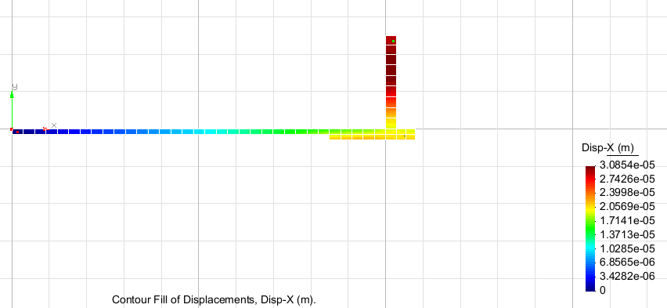
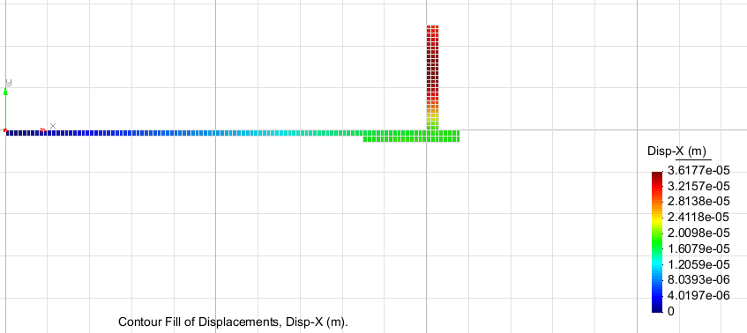
Finer mesh
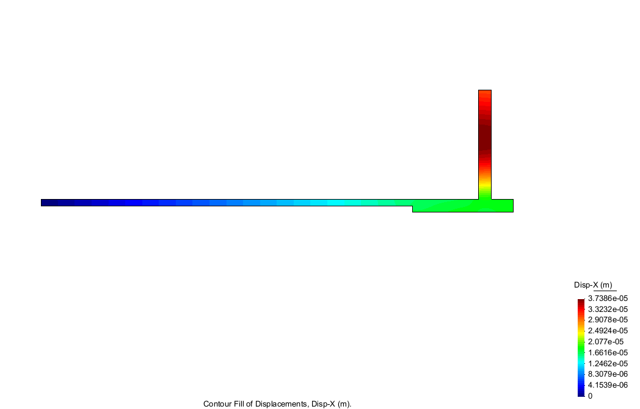
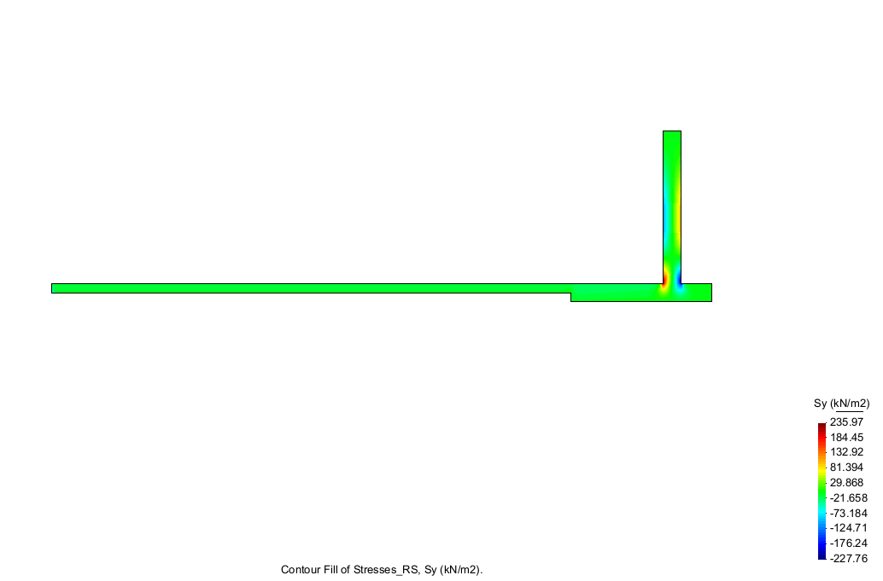
Analysis: The finer the meshes get it results in bigger displacements.
The max stress applied on the structure is 235.97kN/m^2 and the minimum is -227.76 in Sy direction.
Ex 2
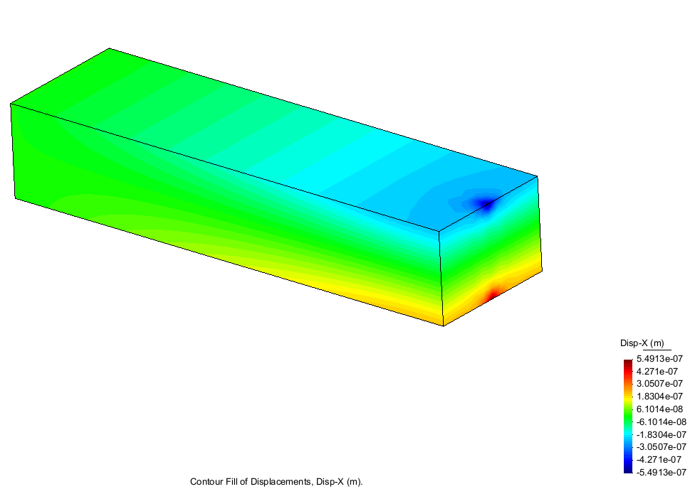
8nodes displacements in x direction
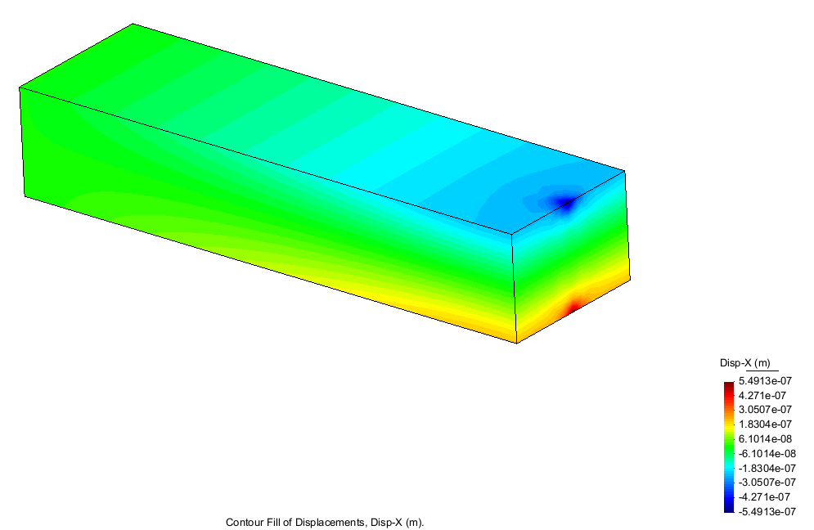
20 nodes displacements in x direction
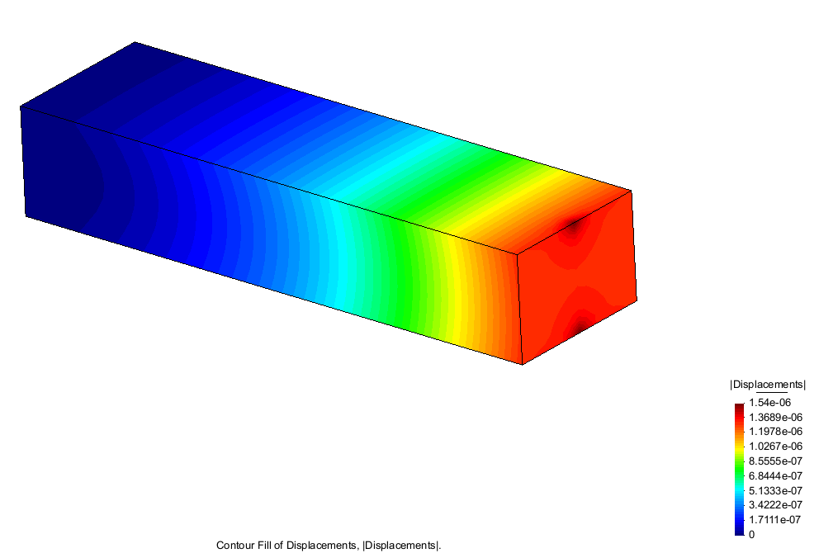
8 nodes total displacements
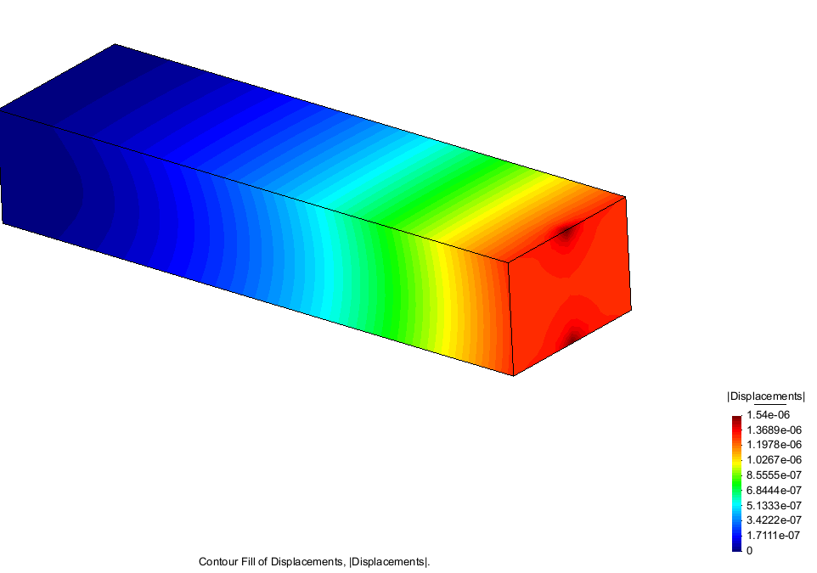
20 nodes total displacements
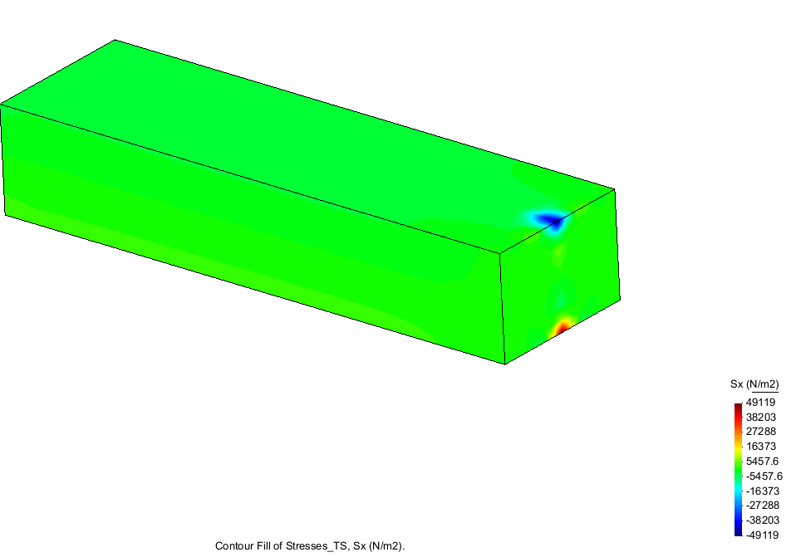
8 nodes Stress in Sx
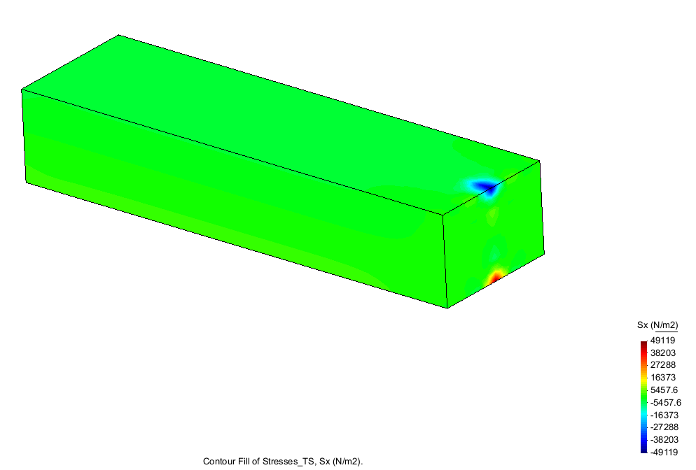
20 nodes stress in Sx
Analysis: The results using 8 node and 20 node hexahedra elements are the same.
Ex. 3
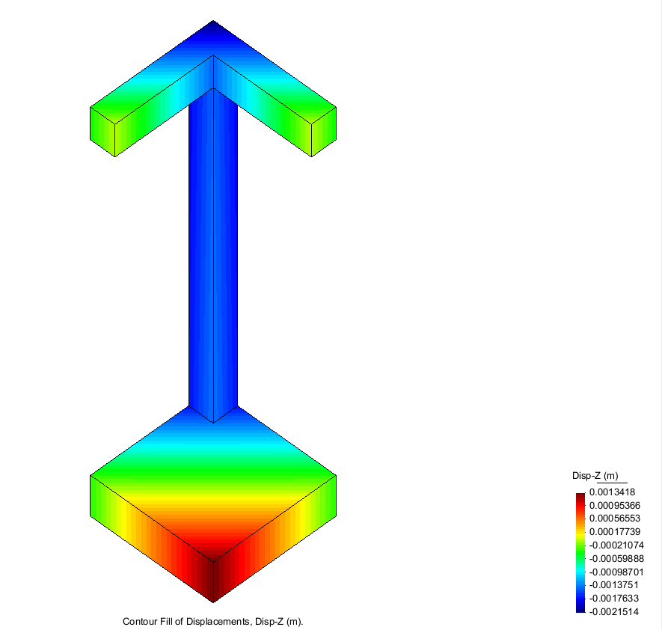 no soil
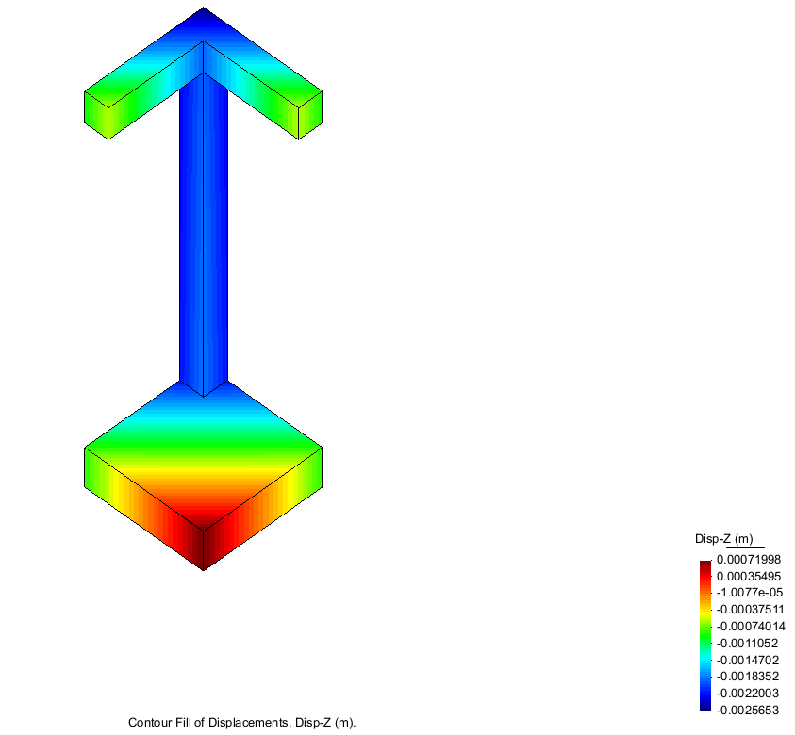soil
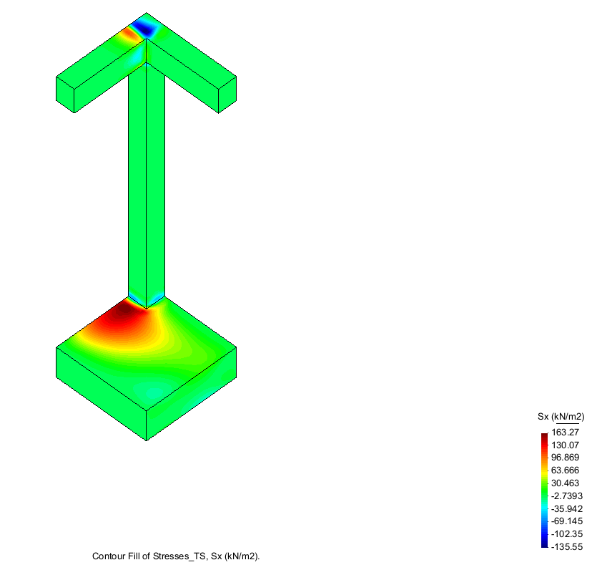no soil
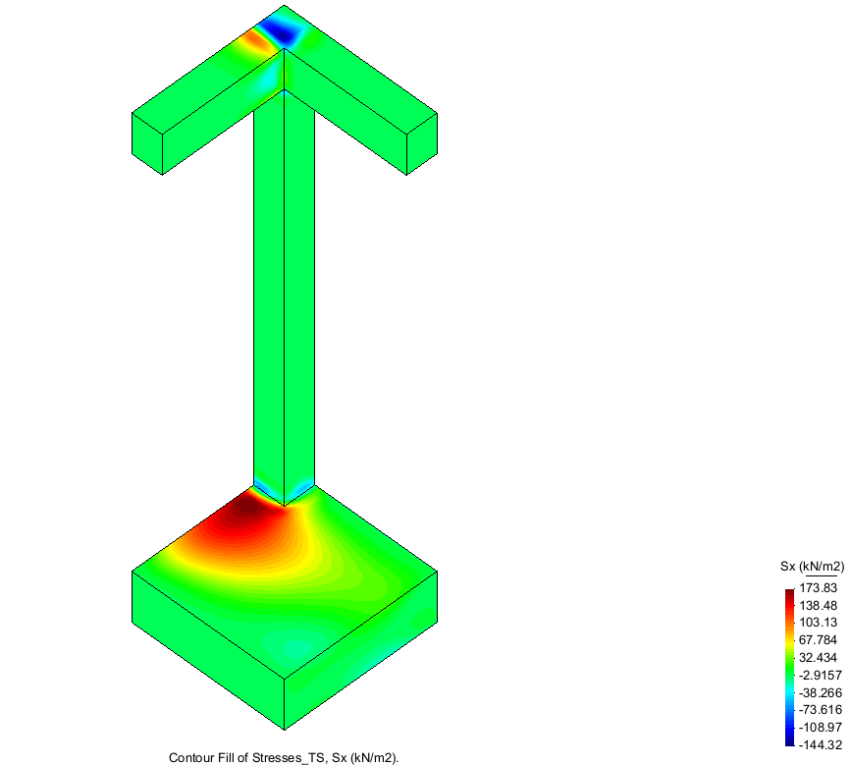soil
Analysis: In the no soil examples Lifting does not occur. And results are smaller than the Soil ones where lifting does occur.

