Practice 5
By
Carlos Moreira, Isperih Daulov, Sungchul Kim

Ex1
Natural Frequency = 1
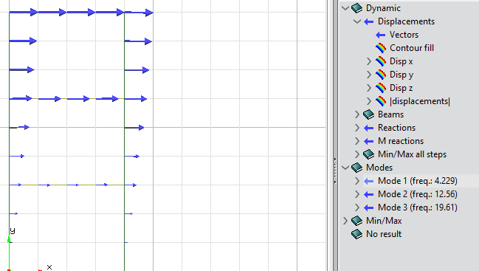mode1
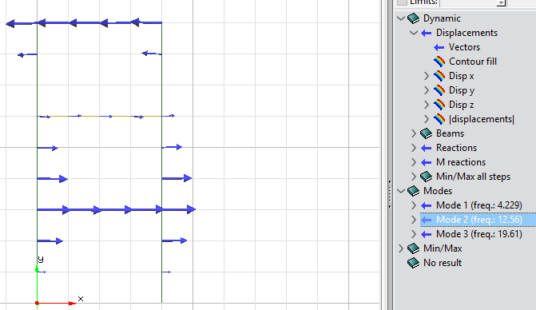
Mode 2
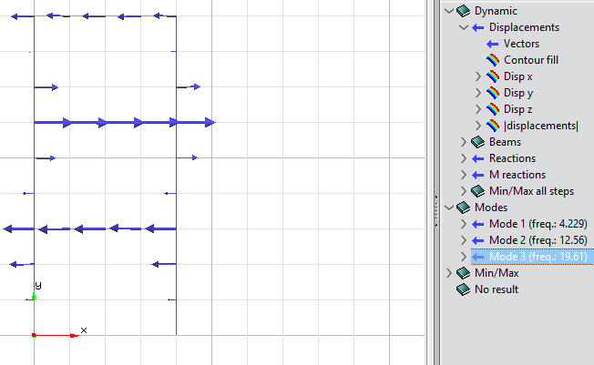mode 3
All 3 modes remain the same for the different models
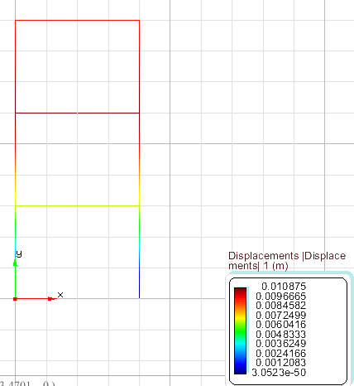Displacements

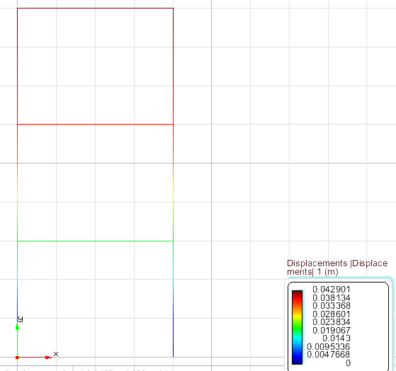Obtained from the Direct integration.

Natural Frequency= 0.75

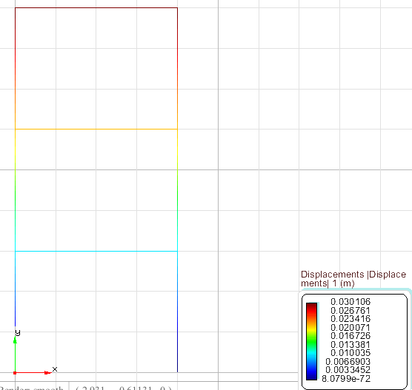Displacements
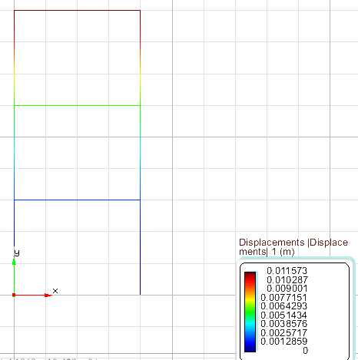Obtained from Direct integartion

Natural Frequency= 1.25
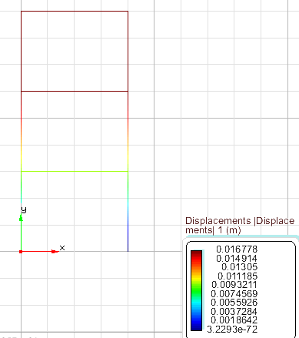Displacements
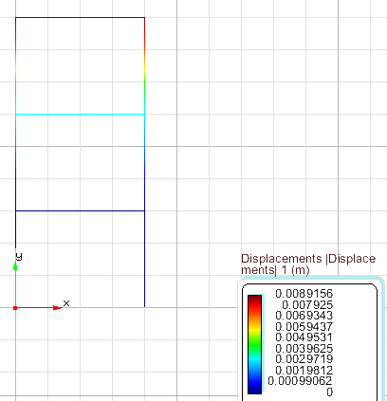Obtained from Direct integration

Analysis: In the direct integration method the maximum displacement is higher and minimum is equal to 0.
Ex2.
10 modes
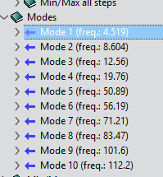
Mode 1
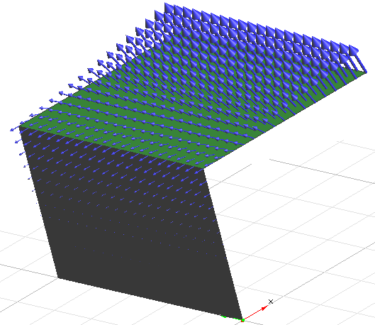
Mode 2
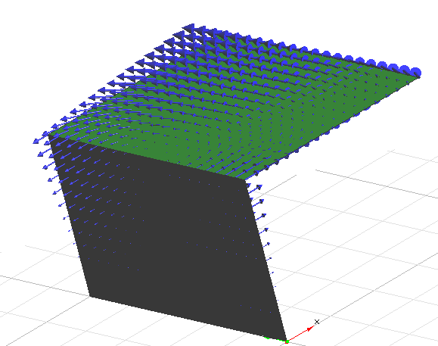

Mode 5
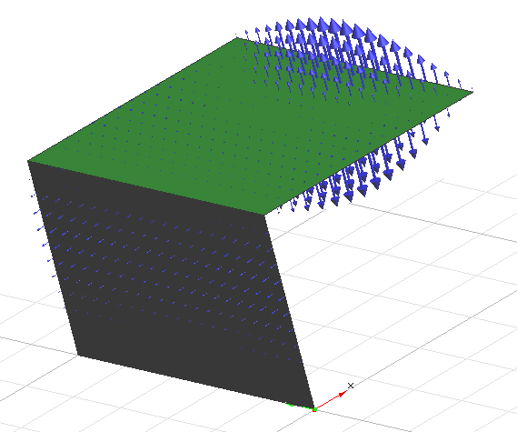
Mode 7
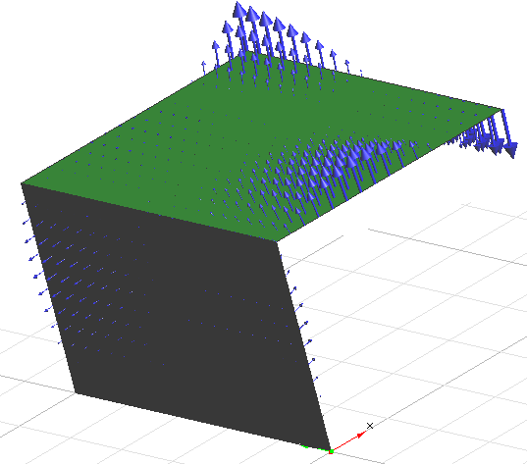

Mode 10
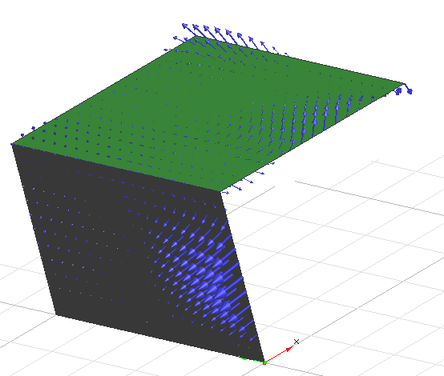
A problem in the work files occurred unable to collect the other data.

